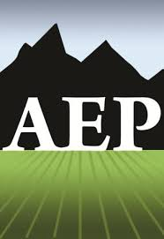  Monterey Bay-Silicon Valley Chapter  To  Enhance,  Maintain,  and  Protect  the  Natural  and  Human  Environment | 2023-2024 AEP Scholarship
$1,500 Scholarship Award
for a community college student

The Monterey Bay - Silicon Valley Chapter of the Association of Environmental Professionals (MB-SV AEP) is offering a $1,500 scholarship to a student interested in studying the environment and exploring an environmental career pathway. Students currently attending community colleges in the Monterey Bay$–$Silicon Valley region are eligible to apply. Winners will be selected based on their academic merit and personal statement, as described on the scholarship application form attached.
Eligibility
- Applicants should have an interest in pursuing an environmentally related discipline in college, such as environmental science, engineering, policy, planning, law, biology, natural resource management or geography.
- Applicants must be enrolled in classes during the 2023-2024 academic year.
- Applicants must attend a community college located within the Monterey Bay/Silicon Valley region. Eligible campuses include Monterey Peninsula College, Hartnell College, Cabrillo College, Gavilan College, West Valley College, Evergreen Valley College, San Jose City College, Mission College, DeAnza College and Foothill College.
- A minimum cumulative GPA of 3.0 is required. Scholarship recipients must provide proof of enrollment for the 2024 winter/spring semester that demonstrates the student is enrolled full-time prior to distribution of the award.
How to Apply
All application materials must be submitted via email by May 10, 2024 to students@aepmbsv.org.
- Refer to the application form below for information about required materials.
- More information about MB-SV AEP can be found online at: https://mbsv.califaep.org/.
- Questions related to the scholarship should be directed to Kayleigh Limbach, Director of Student Programming and Outreach, via email to students@aepmbsv.org.
Scholarship applicants will be informed of decisions by the end of May 2024.
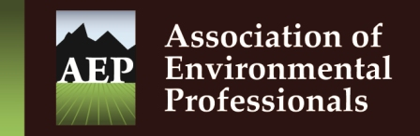
Monterey-Bay Silicon Valley Chapter
2023-2024 Scholarship Application Form
Contact Information
Name
Address
City |  |  |  |  |  | State |  | Zip
Phone |  |  |  | Email
College Attendance

School Name | Dates of Attendance | Degree/Major | GPA
Personal Background
Answers to these questions are not mandatory and are to be answered on your honor, however they will help the scholarship review committee assess applicant’s need for financial aid. Applicants who are of a first generation, low-income and/or an underrepresented background will be given priority during the review process. Yes/No answers will suffice.
- Are you a first-generation and/or low-income (FGLI) student?

- Do you currently receive financial aid from your institution or other sources?

- Are you of a background that is underrepresented in environmental careers (e.g. non-white, non-binary, LGBTQ)?

Additional Application Materials
- TRANSCRIPTS: Include a digital copy of your college transcript(s) with your application. Unofficial transcripts are sufficient.
- PERSONAL STATEMENT (1500 words maximum): The mission of AEP is to enhance, maintain, and protect the natural and human environment. In your personal statement, write about an experience that inspired your interest or curiosity about the environment and describe how you hope to explore that interest as you progress through your higher education.
All application materials must be submitted via email to students@aepmbsv.org by 5 PM on May 10, 2024 for consideration. A single PDF document with all materials combined is preferred, but not required.

