HARTNELLCOLLEGE Travel Guidelines
Plan Ahead
30-45 Days Prior to Travel

Visit the Travel Webpage for Information
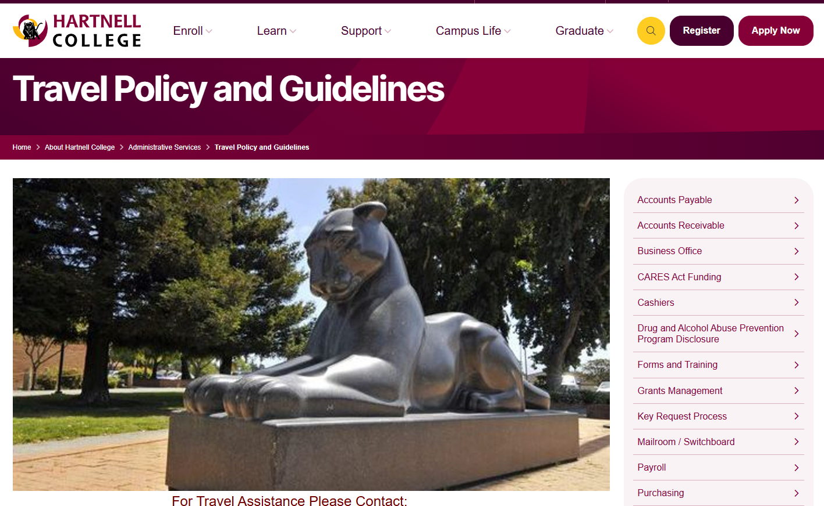

HARTNELLCOLLEGE employees/faculty may not book and/or pay for their own travel arrangements and seek reimbursement. Hartnell Faculty/Staff should go to the support staff of their area/department to seek assistance with travel documents and booking. If there are any Hartnell faculty/staff who do not know who their support staff is that should prepare their documents and book their travel for them, they should speak to their Supervisor/Dean/Director.

Need Travel Arrangements?
Please note the following guidelines are primarily intended to assist those who book travel for others, but may provide some useful information to a traveler as well. These guidelines are not intended to be a tutorial on Concur Travel Software. A reminder, all travel arrangements should be made by the support staff within the traveler’s area/division. Please refer to the paragraph above for guidance.

A Few Thoughtful Reminders…
The Traveler, by signing the Travel Authorization form agrees with the arrangements indicated within, including modes of transportation, and lodging.

Have patience, book early, booking travel for others can include being presented with complex and varying requests, many with multiple options.

Safety, followed by the cost to the District, is recommended to be at the forefront of your decision making when seeking the best solution to multiple travel options.

In these guidelines, you will be advised as the traveler or the travel assistant, to communicate with each other and to agree upon the arrangements being made. The Traveler should have an idea of what they need and the travel assistant should be prepared to research, book, and provide/receive specific and detailed travel arrangements.

Booking late is often time consuming. It can involve sold-out events, rooms offered at special rates (block rate) often sell-out quickly, and airfare is at a much higher cost. Late booking requests cannot be accommodated in some cases. Please try to book direct flights for the traveler’s safety (fewer take-offs and landings).

Driving long distances vs. the cost of flying will undergo a cost comparison analysis. The lesser amount of the two will be reimbursed. Not everything requested may be approved as requested.

New Employee/Traveler? Let’s Get Started…
These guidelines are intended to inform the traveler and those assisting the traveler of the administrative details required to travel. Only support staff, responsible for booking travel, is allowed access to book travel within Concur. Please contact Julia Silveira for questions specific to Concur Software.

Please note, if the travel you are preparing requires a transfer of funds, a budget transfer request and required proof of funding (budget report) should be submitted to Business Services prior to travel. No record of the transfer needs to be included with the packet, however, you must have proof of funding indicating sufficient funds to travel. A budget transfer should never be included in a TA packet.

Request a Concur Profile
Prior to traveling, a new employee will be required to complete and submit a Concur Data Form (available on our travel webpage). The data form is a fillable document, and should be completed online. ALL area’s must be completed, handwritten submissions or those with missing information will be returned. Once completed, please email the data form and 1) a color copy of the traveler’s California driver’s license and 2) proof of liability insurance should be sent to travel@hartnell.edu. A Concur Data form is not to be included in the TA packet.
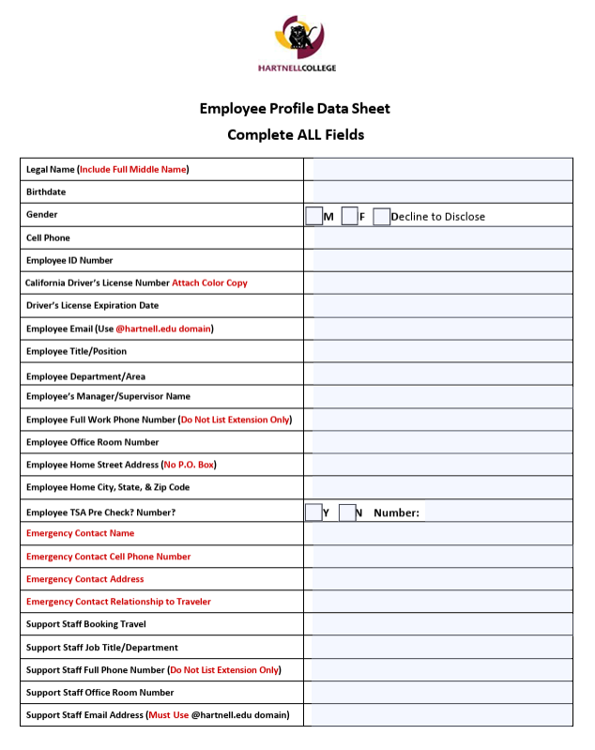

Forms Required
- Concur Data Form
- Travel Authorization Form (Form is dated, select correct year’s form)
- Check Request/s
  - Will be mailed to the address listed on the form.
  - For check pick up, please list “Will Pick Up” in Additional Information
  - A check request is for a single vendor. Multiple check requests require multiple check requests.
  - If included in the TA packet, accountspayable@hartnell.edu must be cc’d in Adobe Sign.
  - Checks will be mailed to the address provided.
  - If check is not to be mailed, indicate Pick Up in Additional Information/Comments box.
- Credit Card Request
  - An appointment is required to use the card; Please contact Lucy Trafton (or Julia Silveira in her absence). There are no appointments after 3:30 p.m.;
  - Bring your signed Credit Card Request form and back up documentation
- Travel Expense Reimbursement Form
  - Requires itemized receipts be attached

Forms Available on the Travel Webpage as below:
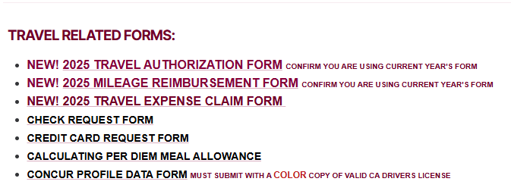
Preparing a Travel Authorization Packet

Prior to booking any travel, a Travel Authorization Packet must be fully completed, signed, and given a TA number. The packet must include all forms necessary to that travel event. This includes items that should not be included in the TA packet such as:
- Concur Data Form
- Budget Transfer Form/s.

The Travel Authorization Form
A Travel Authorization form (TA) is required for approval of off campus travel to attend a conference or a training and when additional reimbursement will be required for expenses other than mileage, such as a registration fee or meal expense. (Travel that is local and that will incur reimbursement for mileage only, and no other expenses, may be submitted on a Mileage Reimbursement form. Please refer to Mileage Reimbursement.).

Completing A Travel Authorization Form
Complete a Travel Authorization form of the current year, available on our travel webpage. Complete all areas as indicated below.

Traveler/Event Information
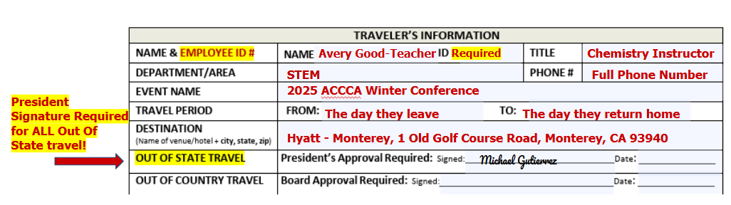

Documentation Required Within Travel Packet for Each Estimate

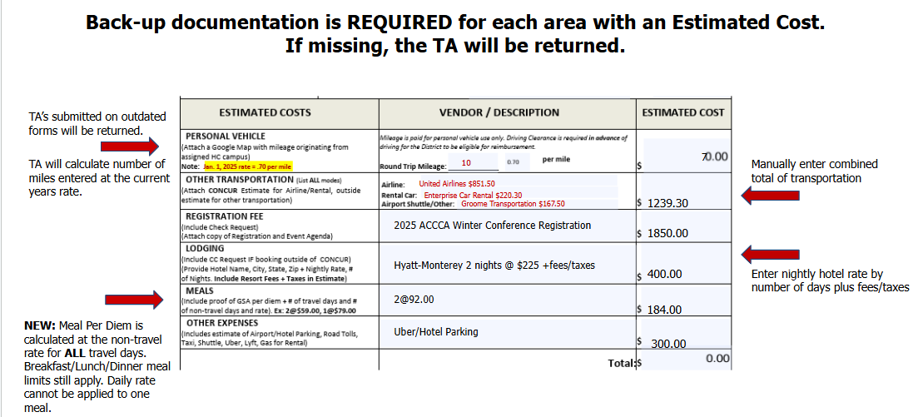

As noted in the illustration above, back-up documents are required for every estimated cost listed on the TA you are preparing. The following is a list of what is required for each travel need:
- Mileage Documentation: Requires a Google map as back-up for the estimated mileage submitted;
- Other Transportation Documentation: Requires screen shots of EACH estimate for EACH mode of transportation listed:
  - Airfare Documentation: Requires a Concur airfare estimate. All airfare for Hartnell Faculty/Staff is to be booked in Concur for that reason, the estimate provided should be a Concur estimate. Concur airfare estimate are good for that day only, when entering the estimated cost for airfare on the TA, be sure to add approximately $150.00 to the Concur estimate.
  - Rental Car Documentation: Enterprise is Hartnell’s preferred car rental and requires a Concur estimate indicating the number of days times the rate of the vehicle selected. The estimate required should indicate cost based on the daily rate of the car you selected.
    - One-Way rentals to/from either SJC or SFO. Please contact Business Services at Ext. 6800 for assistance.
  - Airport Shuttle/Other Documentation: Groome Transportation provides one-way and round-trip shuttle service to/from San Jose Mineta International (SJC) Airport and San Francisco International (SFO) Airport from various points with Salinas/Monterey Peninsula. This service is an alternative to driving to the airport and airport parking.
- Registration Documentation:
  - Registration should be the booked, paid, and confirmed prior to making any other travel arrangements. Booking lodging and airfare before being certain the traveler is in fact registered, can be a costly error.
  - Registration always requires either a Check Request form or Credit Card Request form and a fully itemized estimate/invoice from the training conference/training literature.
    - To use the Hartnell credit card, contact Lucy Trafton (or Julia Silveira in her absence) to make an appoint.
    - The last appointment time of each day is 3:30.
    - The credit card cannot be taken outside of Business Services. Be sure to bring:
      - Signed credit card request form;
      - Back-up documentation.
    - Print or email the receipt to travel prior to leaving Business Services.
  - The registration estimate could be a single all-inclusive fee to attend everything the conference/training has to offer an attendee or the grand total of selected pre-conference offerings and/or individually charged workshops. The registration fee/s total must represent the total dollar amount to attend the conference.
  - A Check Request is the preferred method of payment for conference/training registration, however if the event will not accept payment by check, a Credit Card Request form may be completed in lieu of a Check Request form.
    - If submitting a Check Request form, you must cc accountspayable@hartnell.edu in your Adobe Sign submission, and
      - Include a fully itemized registration invoice indicating total charges.
    - If submitting a Credit Card Request form, you must cc travel@hartnell.edu in your Adobe Sign submission, and
      - Include a fully itemized registration invoice, and back up documentation;
      - Once signed make an appointment to use the credit card (no appointments after 3:30 p.m.
  - Lodging Documentation: Requires an estimate from:
    - Concur; and/or
    - Literature (flyer/email/pamphlet) for the Conference/Training informing attendees they are offering attendees a block of rooms at a special rate specific to the event the traveler is attending. The literature must include:
      - The rate/s (block rate/s) being offered,
      - The date/s the block rates are limited to;
      - The hotel/s who are offering rooms at the block rate/s.
    - A nearby hotel, when there are no block rate/s offered to attendees and no hotels close to the event venue offered in Concur, an estimate may be obtained from a nearby hotel offered at a reasonable cost.
- Meal Documentation: Requires a screen shot of the meal per diem rate according to zip code as below.
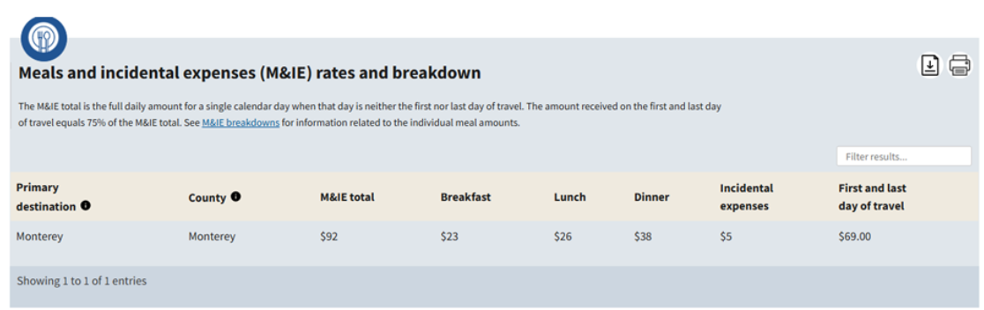

- Other Expense Documentation: This area is the exception to the rule of each area in the Estimated Costs section requiring an estimate. Items listed here are out of pocket expenses and reimbursement may be claimed on the Travel Expense Claim form with a fully itemized receipt.
  - The auditors request specific items be listed here. Do not list Misc. List all items you anticipate the traveler may need such as, but not limited to
    - Hotel Parking,
    - Airport Parking,
    - Hotel Business Center Fee,
    - Road Tolls,
    - Baggage Fees,
    - Uber/Lyft/Taxi Expenses.
- GL# Documentation (Travel Funding): requires either a single source or combination of funding sources to be listed and proof of sufficient funding for each.
  - Proof of funding requires a current Colleague report. If proof of funding is not current or is missing, the packet will be returned as incomplete. All funding sources must be listed. Multi-source funding requires a GL report for each GL. It can be either:
    - A Colleague ACBL report (recommended) for Object Code 55200, or
    - A Colleague GLBS report for object code 55200 only. If not provided, the packet will be returned as incomplete. A single source or combination of funding sources must be listed.
- GL# Documentation (Funding Distribution): GL distribution should appear as below. When funding is coming from multiple GL’s the percentage or distribution of the dollar amount of each account must ultimately total 100% of the travel funding listed on the TA. If not provided, is inaccurate, or has non-sufficient funds to cover the estimated amount of travel, the packet will be returned.
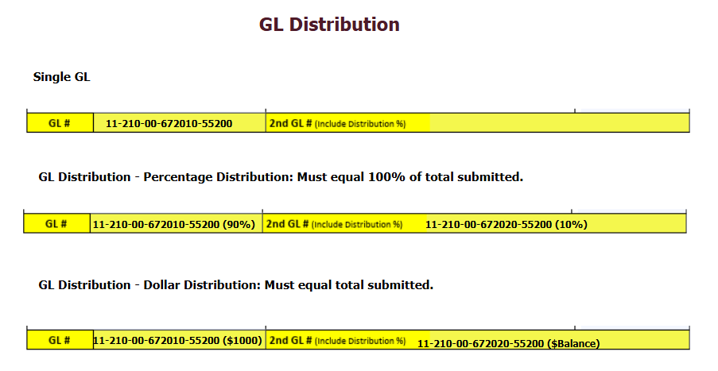
- Proof of Funding Documentation: Proof of funding requires a current Colleague report for Object Code 55200. If proof of funding is not current or is missing, the packet will be returned as incomplete. Please provide either,
  - A single source of funding; or
  - Multi-source funding (which requires a report for each GL). The report can be:
    - A Colleague ACBL report (recommended, and shown below), or
    - A Colleague GLBS report. If not provided, the packet will be returned as incomplete.
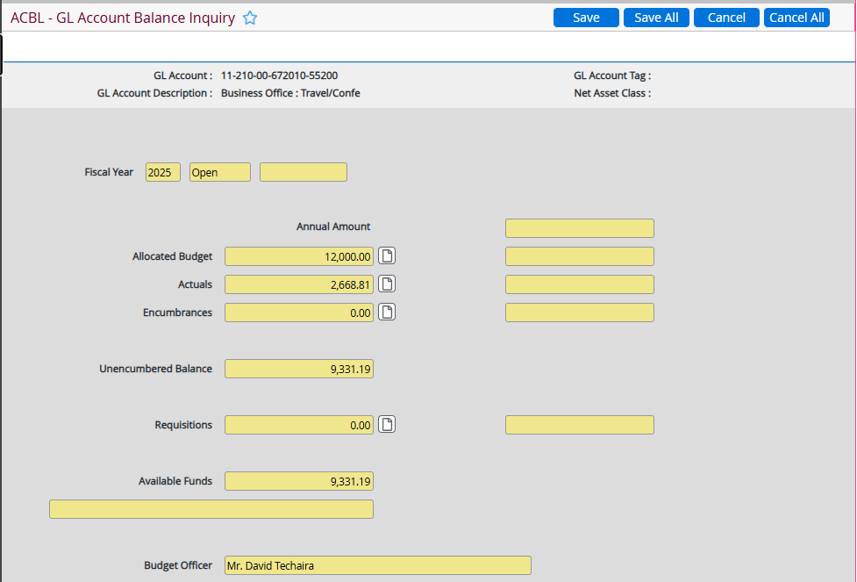

- Outside Funding Documentation: When funding is offered from a Department/Area outside of the traveler’s own Department/Area, it is the responsibility of the funding department to provide proof of funding in a timely manner to the department/area booking the travel. (Please note: Travel is to be booked by the support staff within the traveler’s department and not by the department/area providing the funding for the travel).

Documents That Should NOT be Included in TA Packet
- Concur Data Form
- Driving Credentials
- Budget Transfers

Group Travel
In some circumstances, group travel may be processed differently than individual travel and exceptions to individual travel policy procedures may be made. Should leadership choose to select and send a group of faculty/staff to an event as a group, they may also choose to have one person to organize the event, either by preparing all of the travel documents and/or making all of the arrangements for the group. Please notify Julia in Business Services when planning group travel.

In some circumstances, travelers may learn of other colleagues attending an event they are attending. Should colleagues choose to come together as a group, every effort will be made to assist when possible. Please contact Julia in Business Services for assistance.

Authorization and Submission of the Travel Authorization Packet
The Traveler, by signing the Travel Authorization, acknowledges that all arrangements listed therein have been discussed with them by the Travel Assistant, and agreed upon.
To ensure the proper signatures are present, it is necessary to know who manages all of the budgets involved in funding the travel packet you have prepared.
- Travel Packet: A travel packet should include:
  - A fully completed Travel Authorization form;
  - All supporting/back-up documents including:
    - Cost estimates;
    - Colleague proof of funding for object code 55200:
      - GLBS report; and/or
      - ACBL report (preferred).
  - All required signature/s must be present.
  - When travel is funded by more than 1 budget and more than 1 budget manager,
    - Both/All budget managers must sign;
    - A copy of both/all GL’s must be attached.
  - Out of state travel must be signed by the President.
  - Out of country travel must be signed by the Board.
  - The travel packet must include all signature as illustrated below:

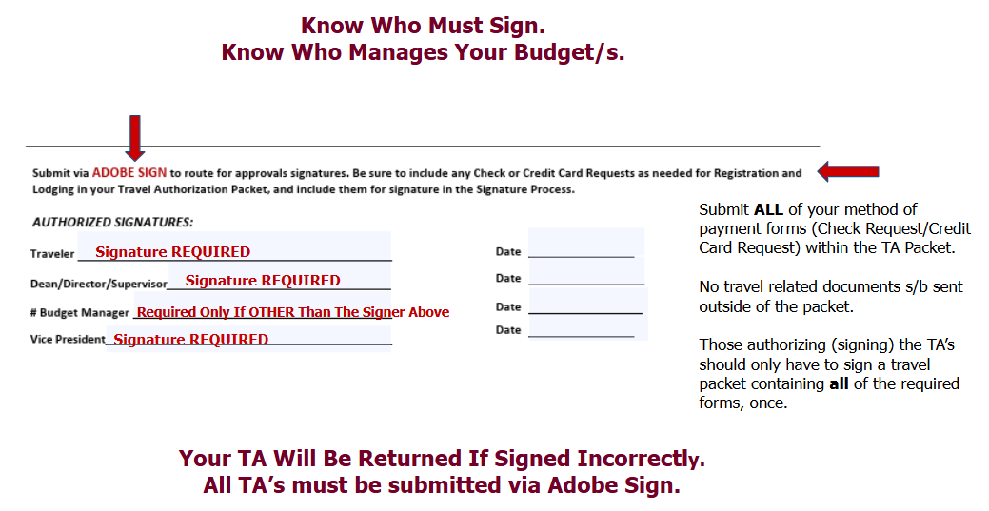

Travel by Vehicle
Driving Clearance
Required for both Personal/Rental Vehicles
- Apply for clearance a minimum of two weeks prior to the first date of travel to allow time for the DMV to process;
- The driver’s liability insurance coverage is primary and intended to cover any/all damage or loss to an employee’s car;
- The District’s coverage, when applicable, is secondary;
- Once driving credentials have been submitted and verified by the DMV, and clearance has been obtained, it must be maintained as current;
- Submission of current documents to maintain driving clearance is up to each employee to submit;
- Reimbursement is authorized for approved use only of a personal or rental vehicle and only after appropriate driving credentials are received and processed, and clearance has been issued;
- Please note that mileage reimbursement is meant to cover only those miles incurred above and beyond the employee’s normal commute to his/her place of business;
- Driving credentials are required to receive clearance to drive both personal/rental vehicles.
- Apply for clearance a minimum of two weeks prior to the first date of travel to allow time for the DMV to process
- Submission of driving credentials is up to each employee to submit; Credentials required are:
  - Color Copy of valid California driver’s license. Clearance cannot be granted on out of state licenses; and,
  - Liability Insurance:
    - A copy of the front and back of your current liability insurance card is required.
    - As the expiration date is reached, a new copy of your current liability coverage will be required to maintain your clearance.
  - Apply for clearance a minimum of two weeks prior to the first date of travel to allow time for processing.
    - The traveler is the only driver allowed to drive their rental car;
    - A full-size car is always recommended for safety;
    - An SUV may be rented when traveling into inclement weather. Please contact Business Services at Ext. 6800 for assistance.
    - Vans for groups may be rented. Prior to submitting your TA, it is recommended to call the Enterprise office you intend to pick up from and inform them of your need for a van. Vans are not always available on-site, you must contact the pick-up location office to arrange for vans. Please contact Business Services at Ext. 6800 for additional assistance.

Airport/Airfare Guidelines – Book in Concur
- More than any mode of transportation, a conversation with your traveler is strongly recommended to DISCUSS SPECIFIC FLIGHTS DESIRED. If the traveler does not reach out to you to do this, you MUST reach out to them. Communication with the traveler is REQUIRED PRIOR TO BOOKING AIRFARE; The traveler should make the final choice of what flights work best for their needs.
- All airfare is to be booked in Concur;
- All airfare should be booked at least 30 days in advance;
- No airfare should be booked more than 90 days in advance;
- No Credit Card Request form is required;
- Economy Refundable Tickets are recommended and are the most widely purchased tickets due to their lower rates, on approval of the budget manager, refundable tickets may be booked at the higher rate, when there is a concern.
- Book Non-Stop Flights: For safety, all flights should be booked as non-stop; If the traveler is flying out on Monterey, and requires a connecting flight, SFO or LAX are highly recommended as they have many direct flights available.
- Local Airports: In most circumstances, airfare should be booked in/out of local airports; however, some exceptions may apply. Please notify Julia Silveira in Business Services when flights are not booked in/out of local airports shown below. Local airports would include the following:
  - SFO – San Francisco International Airport
  - SJC – San Jose Mineta International Airport
  - MRY – Monterey Regional Airport.

- Connecting Flights:
  - Booking connecting flights on different airlines, is not recommended. If this practice cannot be avoided, sufficient time between flights must be allowed for the traveler to not only retrieve their luggage but to check their luggage onto the other airline. Contact Julia Silveira in Business Services prior to booking connecting flights on different airlines.
  - If the traveler is flying out of Monterey, and requires a connecting flight, SFO or LAX are highly recommended.
  - Confirm any layover time indicated on a flight is not excessive and that the traveler is aware and agrees with the booking.
- Baggage: Baggage is allowed as follows:
  - 1 bag for 1-4 days of travel;
  - 2 bags for 5 or more days of travel;
  - Baggage is an allowable out of pocket expense and may be claimed on the Travel Expense Claim Form with valid itemized receipt/s. Baggage in excess of guideline listed above is not reimbursable.
- Airport Parking:
  - Airport Parking is an allowable out of pocket expense; however, all faculty staff are encouraged to look into the Groome Transportation shuttle service to/from airports.
- Mileage To/From Airport: Is and allowable out of pocket expense and may be claimed on the Travel Expense Claim Form. See Mileage Reimbursement Guidelines.
- Special Services:
  - All airfare booked with Concur assumes economy seating. Upgraded or preferred seating may not be booked without prior approval. In most cases preferred seating must be requested and paid by the traveler. Flights of greater than 5 hours, can be evaluated on a case by case basis, in advance of booking the airfare, and must be approved in advance by the Budget Manager. If requesting an upgraded seat due to Medical Necessity or ADA, relevant documentation, (such as a doctor’s note) will be requested to assist in the determination.
  - Most special services are at the cost of the employee and not refundable.
- Cancellations: Contact Julia Silveira in Business Services to make all airfare cancellations. Contact a Concur representative (the number should appear on your Concur itinerary) for emergent after-hours cancellations. Please note that Hartnell will be charged a fee for after-hours assistance, and this service should only be utilized in emergent situations.
- Airport No Shows: Should you decide not to fly for any reason, you must contact Julia in Business Services or a Concur representative after hours. Contact information should be available on your Concur itinerary. An airfare No Show forfeits the cost of the ticket and the department will be charged.
- Layovers: Booking non-direct flights can have consequences for the traveler. It is recommended that when you cannot book connecting flights with the same airline, that you allow sufficient time between flights to retrieve you checked bagged from the first airline and to check it aboard the new airline.
- Early/Late Arrival Times: Reasonable lodging accommodations may be made depending upon conference start/end times and the approval of the Budget Manager. Contact Julia Silveira in Business Services for assistance.
- Economy Refundable Tickets are recommended and are the most widely purchased tickets due to their lower rates, on approval of the budget manager, refundable tickets may be booked at the higher rate, when there is a concern.

Booking Enterprise Car Rentals in Concur:
- A conversation with your traveler is highly recommended to establish what they require in a rental car. You must confirm the traveler’s desired pick-up and drop off dates/times before you book. Concur requires this. You must ensure that your traveler is aware of their responsibilities involved in car rental. The pick-up and drop off time are scheduled on the quarter hour.
- Be sure to inform your traveler that arriving late to pick up a vehicle can result in the car being rented to someone else and no car being available to them. The traveler must be on time to pick up their car.
- To drive, a traveler must have established driving clearance at least two weeks prior to the date of travel;
- The traveler will be the only driver allowed to drive;
- No Credit Card Request form is required;
- A full-size car is always recommended for safety;
- An SUV may be rented when traveling into inclement weather. Please contact Business Services at Ext. 6800 for assistance.
- Vans for groups may be rented. Prior to submitting your TA, it is recommended to call the Enterprise office you intend to pick up from and inform them of your need for a van. Vans are not always available on-site, however, they can request them from other location to arrive locally prior to your dates of travel. Please contact Business Services at Ext. 6800 for additional assistance.
- Expenses for Uber/Lyft are not reimbursable when a renting a vehicle has been provided;
- Groups:
  - Hartnell no longer has vans to loan on any campus;
  - Vans for groups may be rented. Prior to submitting your TA, it is recommended to call the Enterprise office you intend to pick up from and inform them of your need for a van. Vans are not always available on-site from the vendor, they must be requested prior to the dates of travel. Please contact Business Services at Ext. 6800 for additional assistance.
  - Cars will not be rented for all parties when attending a departmental group conference/training. Please contact Business Services at Ext. 6800 with any questions or for assistance.
  - One-way rentals: May be an available option based on approval from the Enterprise office you are renting from. Availability needs to be confirmed prior to booking a one-way rental. Contact the local vendor to confirm availability in advance of dates of travel. Please contact Business Services at Ext. 6800 for any additional assistance you may require.
- Mileage Reimbursement When Renting A Vehicle:
  - Mileage Reimbursement may not be claimed when using a rented vehicle as it is intended to provide reimbursement for gas and wear and tear on an employee’s personal vehicle.
  - Gas is an allowable reimbursable expense when:
    - Driving clearance has been obtained in advance; and
    - Itemized receipts are provided with the Travel Expense Claim form.
    - Hartnell Gas Cards: Are also available for use when traveling. See below.
  - Hotel Parking is an allowable reimbursable expense. Itemized receipts are required.

- Hartnell Gas Cards:
  - A Hartnell gas card may be obtained from and returned to Angie Jacobo (ajacobo@hartnell.edu) in the Maintenance/Facilities office.
  - A Hartnell gas card may be used when driving:
    - A Hartnell owned vehicle;
    - A rented vehicle for team transport or a group attending an authorized event.
    - A Hartnell Gas card if not allowable for use with personal vehicles;
    - Return the card and receipts for charges to Angie Jacobo upon return.

Guidelines for Booking Hotel Lodging
- Requires a conversation with your traveler to learn details about the event and what the event is offering. Some events offer rooms to attendees at a special rate. You need to what has been made available to the traveler. If the traveler does not provide you with this, you must ask them. If they do not know, it is their responsibility to find out what the conference is offering to ensure you know how to proceed. Communication is required.
- Confirm if rooms are being offered at a special rate (block rooms) for attendees;
- Confirm you have a signed Credit Card Request form within your signed TA packet;
  - If booking during an appointment in Business Services, bring this with you;
- Sold-Out Block: Available rooms offered at the block rate provided by the conference, often sell out quickly. For safety, every effort should be made to acquire a room for the traveler where the event is being held at the block rate. Unfortunately, without the special pricing, some venues will be too expensive. In those cases, call the hotel where the event is being offered and ask which nearby hotel/s they recommend.
- Hotel Parking is a reimbursable expense. Itemized receipts are required.

Booking Hotel Lodging Outside of Concur Due to Special Rates Offered
- If yes (rooms at a special rate are being provided to attendees), you must book the room directly with the hotel. To book directly:
  - Contact Lucy Trafton (or Julia Silveira in her absence) for an appointment to use the Hartnell credit card;
  - During your appointment, be sure to bring a copy of the signed Hartnell Credit Card Request form with you;
  - Call the hotel to make the reservation for the traveler, make note of the confirmation number, you will need it later;
  - If booking for more than 1 person, travel will need each person’s confirmation number;
    - Get the name of the person you spoke to, you will need it later;
    - Ask the hotel (exception: Hyatt) to email a Credit Card Authorization form/link directly to the travel email address; (Note: Be sure you are speaking to the property where the traveler will be staying and not to the national reservation number);
  - If booking for more than 1 person, ask the hotel if you need individual Credit Card Authorizations for each guest, or if all of those you are booking for can go on 1 authorization;
    - Email the following to travel:
      - The name of the person you spoke to;
      - The confirmation number/s. If booking for more than one traveler, be sure to provide travel with the confirmation number for each traveler;
      - Confirm that you requested the hotel to send their Credit Card Authorization form directly to the travel email account. If not received, you will need to call again;
      - If Hyatt Hotel, inform travel that you did not request a Credit Card Authorization form/link was requested as the reservation is with the Hyatt;
      - Travel will email confirmation of the Credit Card Authorization form when received;

Booking Hotel Lodging in Concur – No Special Rates Being Offered
- If no rooms are being provided at a special rate to attendees, book the room via Concur.
  - Reserve room in Concur; You can only book for one traveler at a time within Concur;
  - Upon reserving a room in Concur, make note of the confirmation number, you will need this later;
  - Call the hotel, get the name of the person you spoke to, you will need it later;
  - Ask the hotel (exception: Hyatt) to email a Credit Card Authorization form/link directly to the travel email address; (Note: Be sure you are speaking to the property where the traveler will be staying and not to the national reservation number);
  - Email the following to travel:
    - The name of the person you spoke to;
    - The confirmation number/s. If booking for more than one traveler, be sure to provide travel with the confirmation number for each traveler;
    - Confirm that you requested the hotel to send their Credit Card Authorization form directly to the travel email account. If not received, you will need to call again.
    - If Hyatt Hotel, inform travel no Credit Card Authorization form/link was requested as the reservation is with the Hyatt
    - Travel will email confirmation of the Credit Card Authorization form when received;

Guidelines for Reimbursement
Long distance mileage will undergo a cost comparison analysis to determine if airfare is lesser in cost. Mileage in excess of the cost of airfare will be reimbursed at the cost of airfare.

Meals will be reimbursed up to the allowable rate only. The daily reimbursable rate cannot be applied to a single meal.
Travel Expense Claim Form

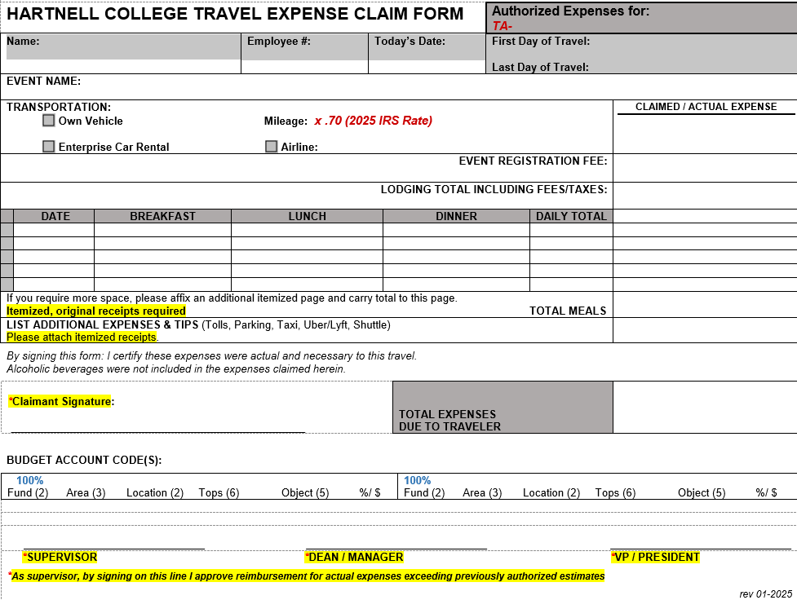

Guidelines for Fieldtrips: A Travel Authorization form (TA) should be completed for the faculty/staff leading the Field Trip. ALL STUDENT EXPENSES SHOULD BE ACCOUNTED FOR ON THE TA OF THE FACULTY/STAFF LEADING THE FIELD TRIP.
- The TA packet should be completed in the same manner AND include ALL the same forms AND supporting documentation as indicated in these guidelines, AND the required Field Trip forms for EVERY STUDENT ATTENDING. ALL STUDENT EXPENSES SHOULD BE INCLUDED ON THE TA FOR THE FACULTY/STAFF LEADING THE FIELD TRIP.
- Please direct all questions pertaining to Field Trip forms to Academic Affairs.

