- Access ESM Solution Login page: https://esmsolutions.com/customer-login/
a. Click on “ESM Solutions” under the Customer Login section:
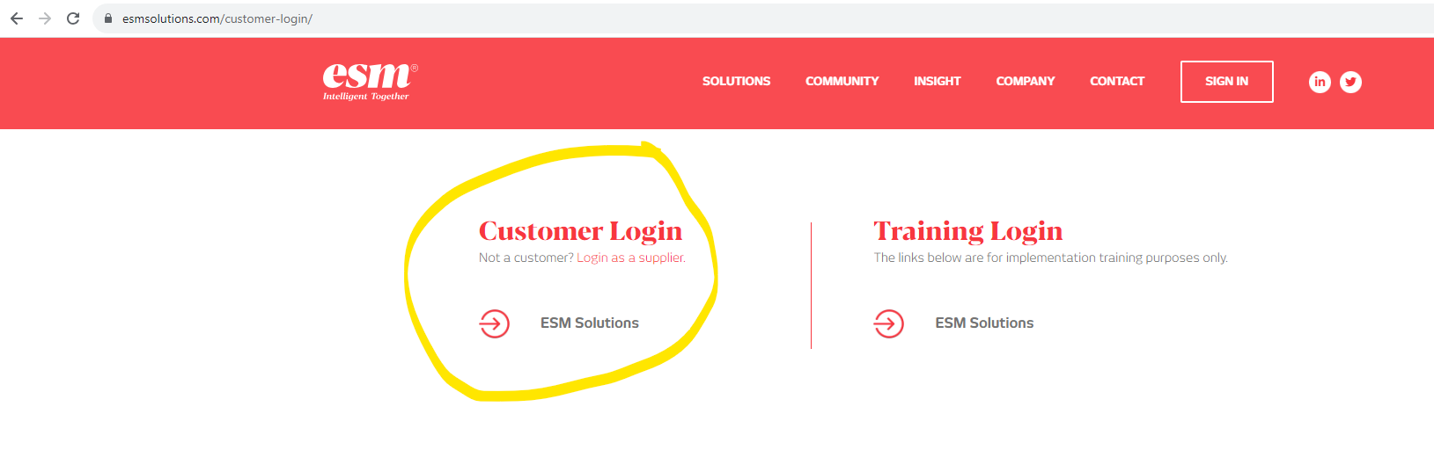2. Enter your email address and password here:
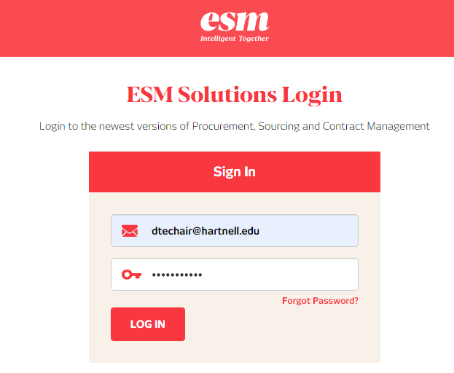
- To enter a requisition, click “Shop” at the top left to enter a manual requisition or click one of the punchout catalogs at the bottom (e.g. “Blick Art Materials”, “Carolina Biological”, “CDW”, or for Office Depot, click on “ODP Business Solutions”).

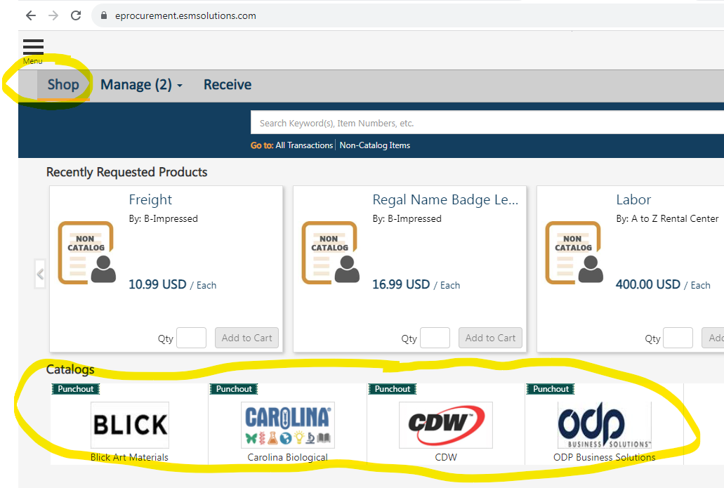

- Clicking on a punchout catalog will result in a separate window opening with that vendor’s webpage.
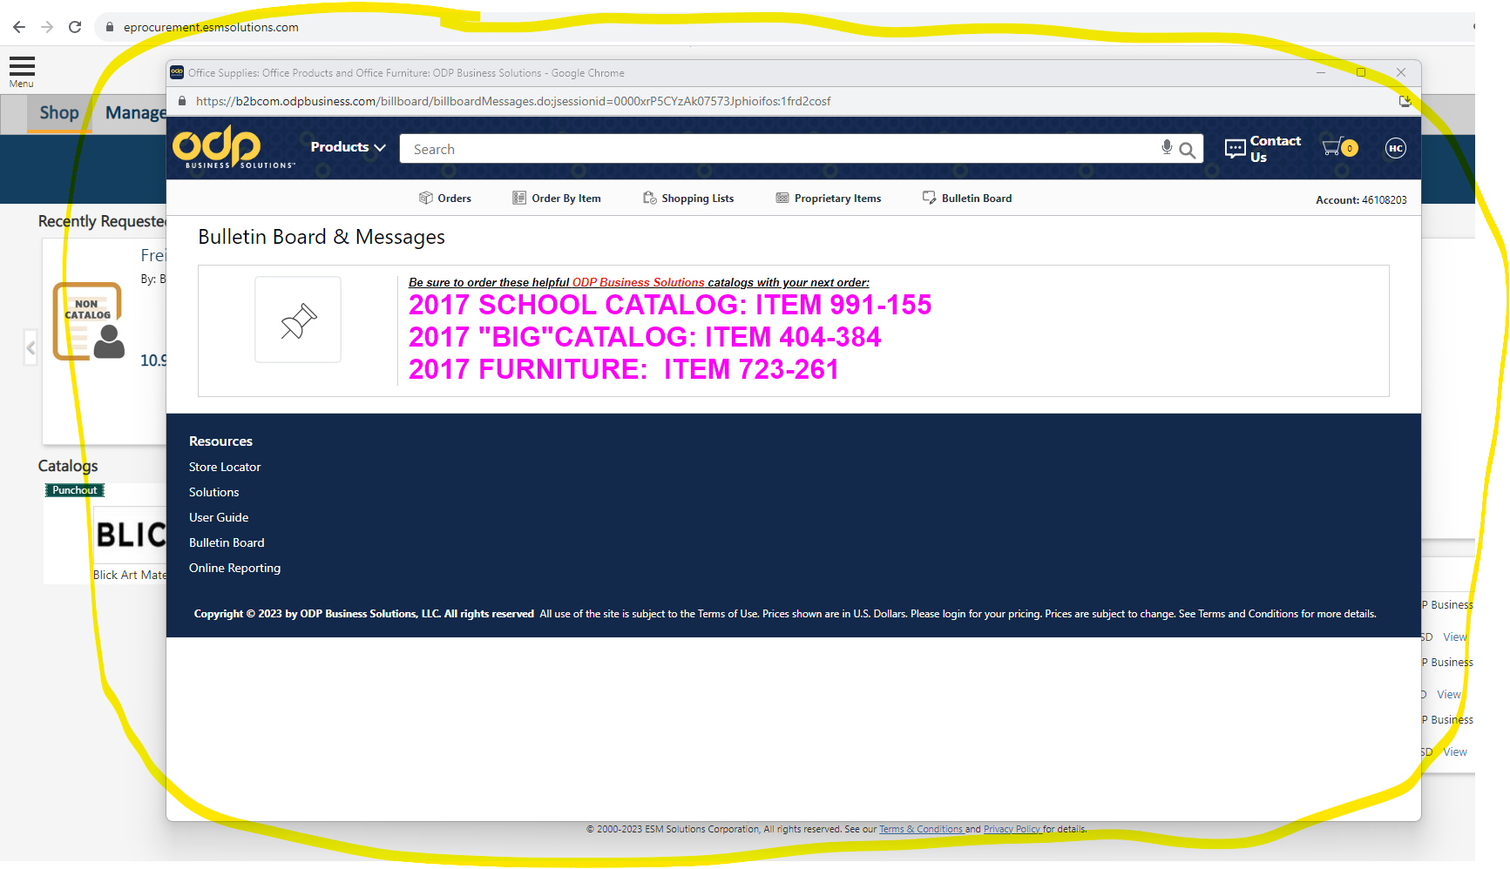
- Search for items and add items to your cart. When finished click “Checkout” and you’ll return to ESM where an item summary will be presented. Review the information here and click “Checkout”

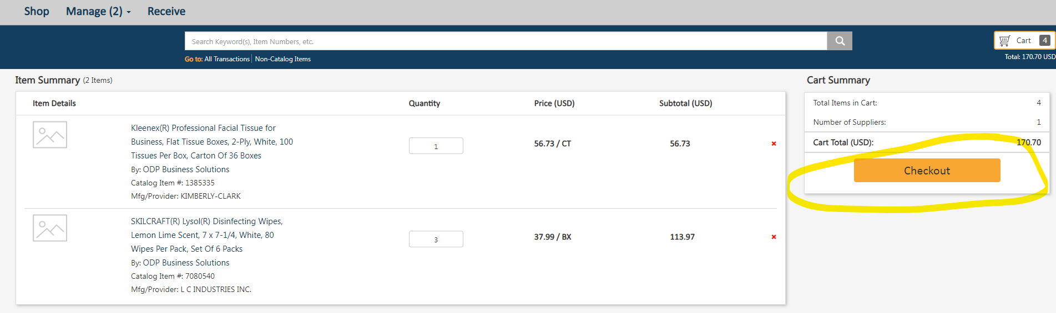

- Click “ Yes” to continue with the order
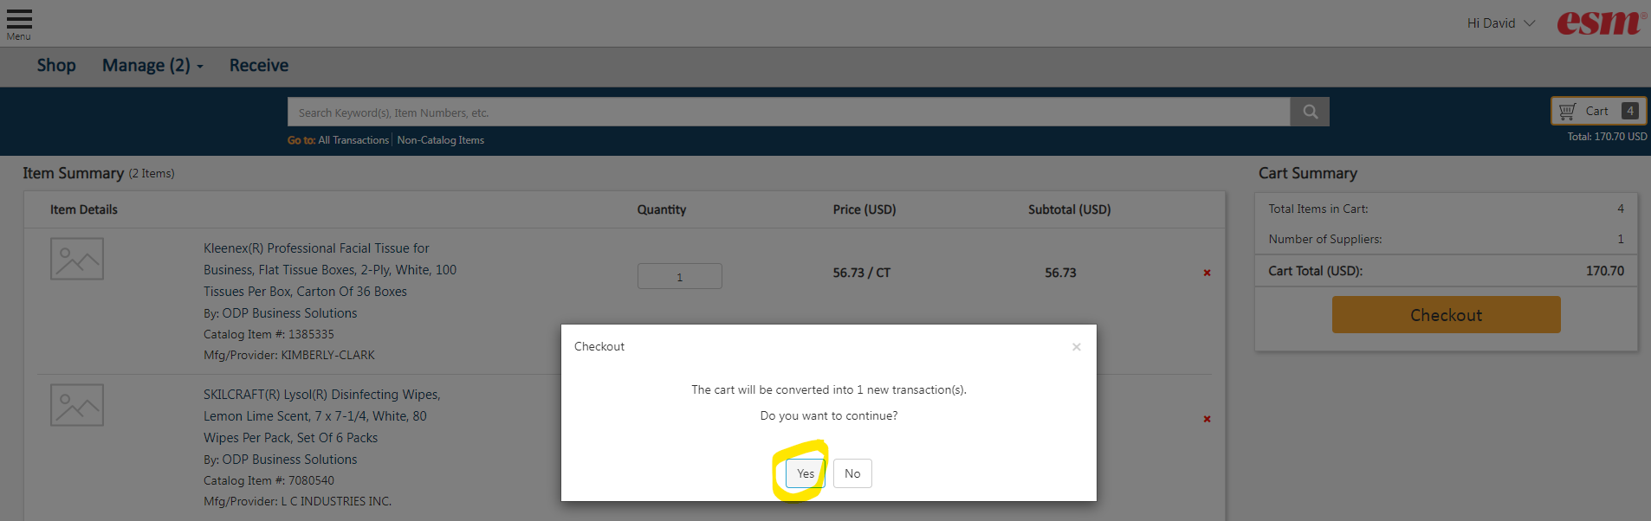
- You’ll be presented with the Checkout screen below. Review each section.
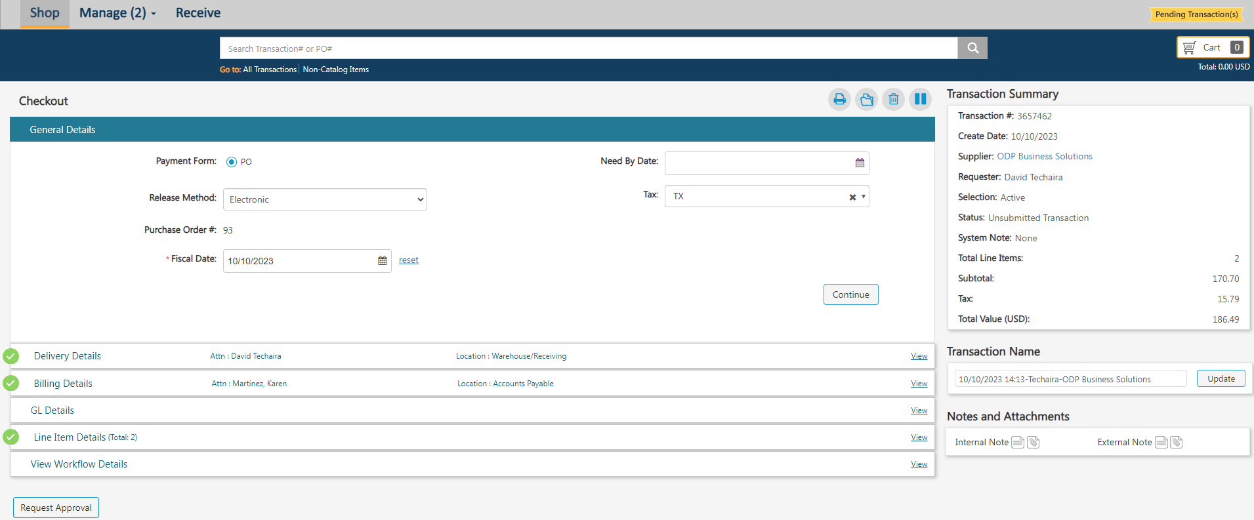
d1. The information in the “General Details” section will default. You will not need to change anything, so press “Continue” to proceed to the next section.
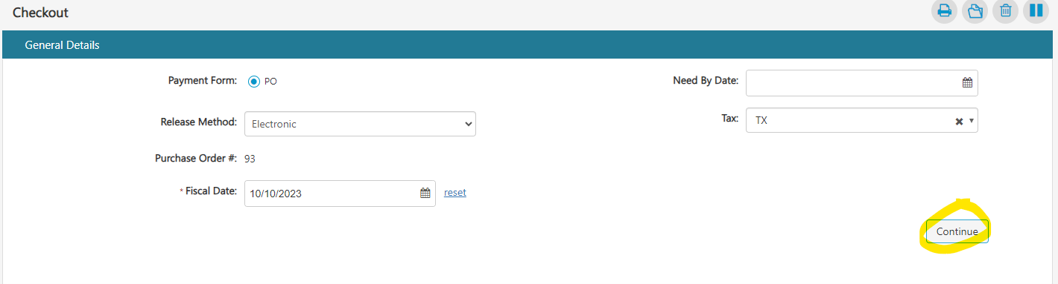

D2. In the “Delivery Details” section, enter the person’s name to receive the order in the “Ship To – Attn:” field. Then search and select the delivery location and click “Continue.”
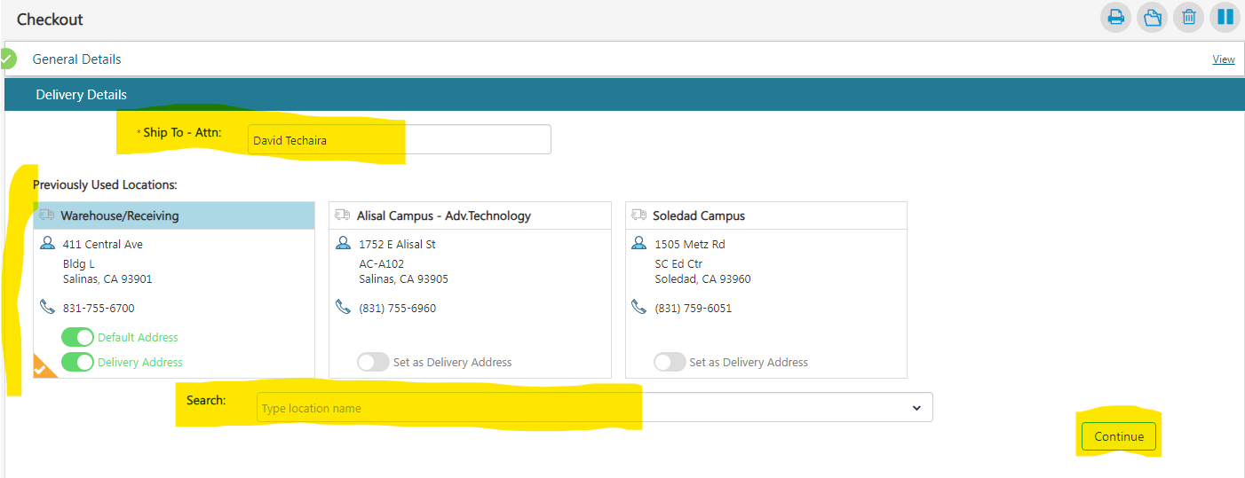
D3. In the “Billing Details” section, click “Continue.” No information should be changed here.
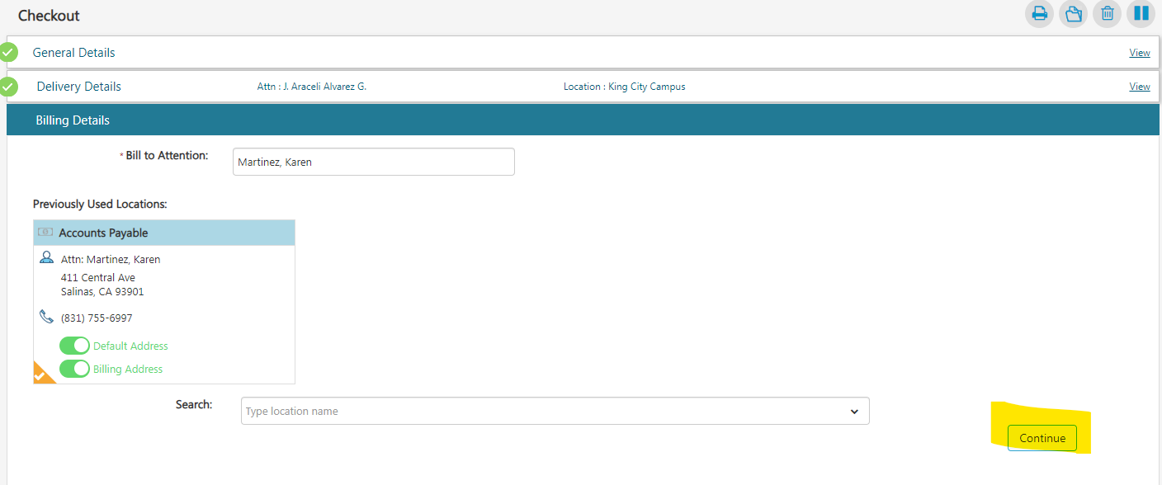
D4. In the “GL Details” section, account numbers must be entered. Click on the + sign at the right and enter the account number components (Fund, Area, Location, TOPS, Object). Click “Apply” when finished.
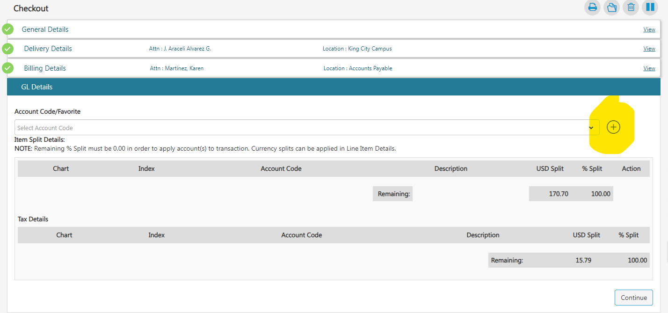
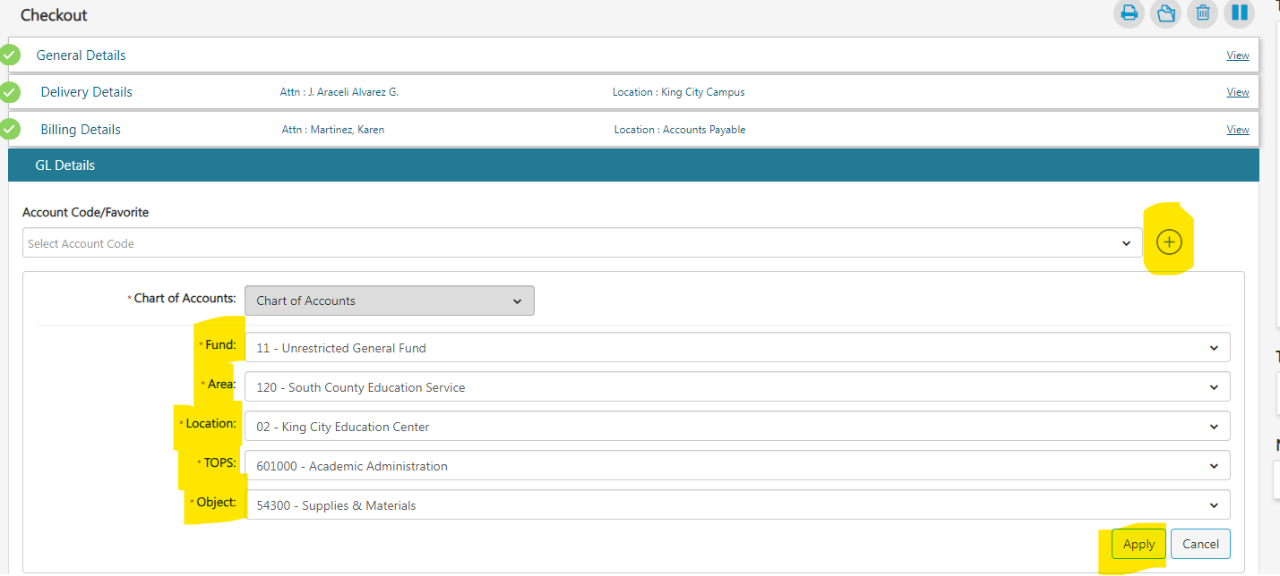
Review the gl account information for accuracy and click “Continue”
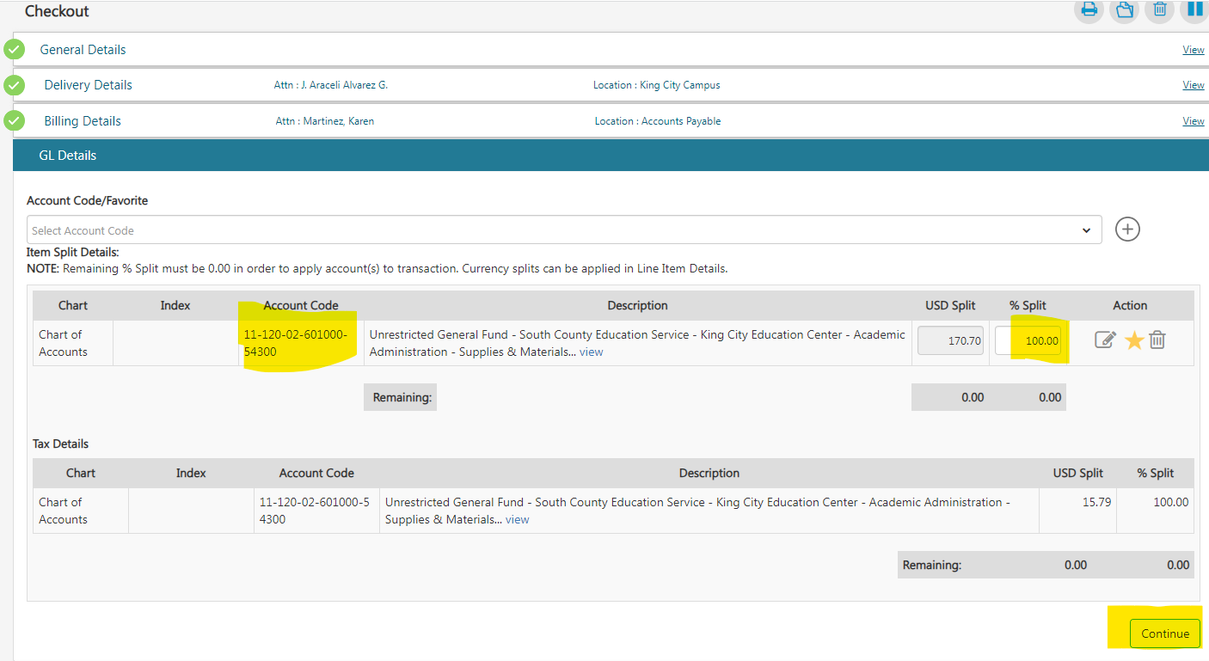
D5. In the “Line Item Details” section, review/confirm the information and click “Continue”
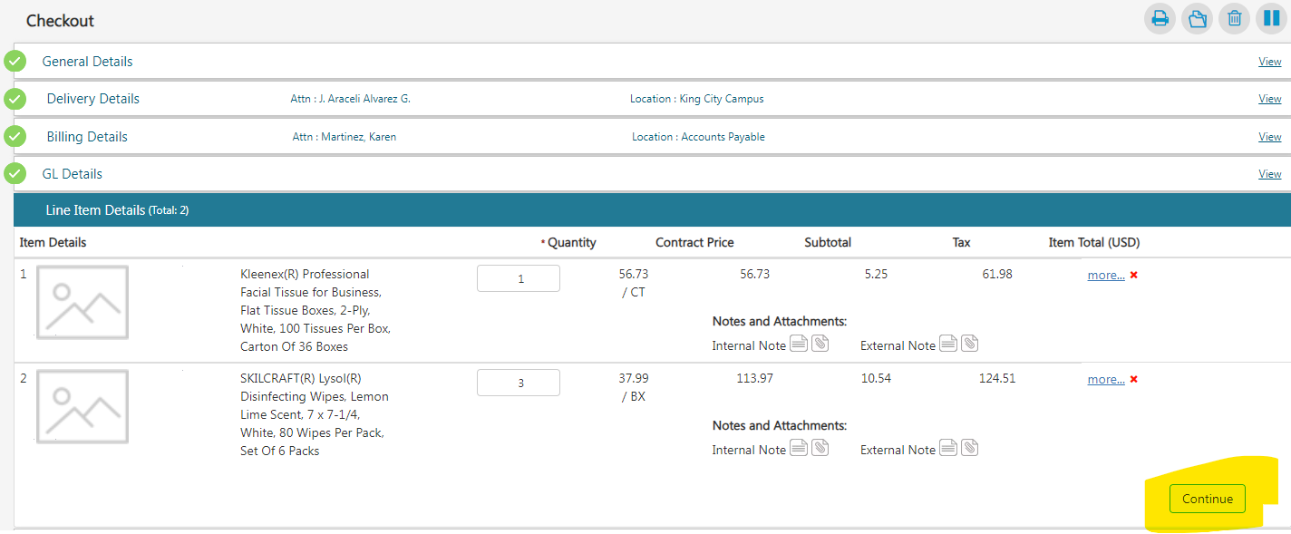
D6. The last section, “View Workflow Details” will show you who the request will get routed to for approval. Nothing can be changed here, but let Purchasing know if the routing is incorrect.
D7. If you have quotes and/or notes to provide, do so at the bottom right corner under the “Notes and Attachments” section. Click on either the notes icon or attachment icon and provide inputs/attachments. Please note that internal notes/attachments do NOT get sent to the vendor. External Notes get sent to the vendor, so notes should include the quote/proposal number, and the attachment should be the actual quote/proposal document the vendor provided.
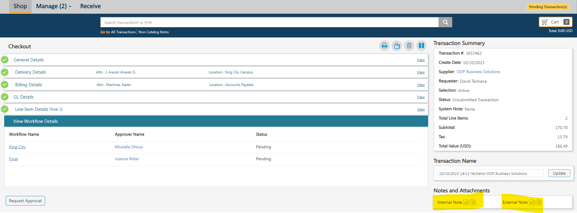
To attach documents, select the paperclip icon and a screen will open to allow you to attach. Select “Choose file” at the right, find the document to attach, and click “Update.” You’ll return to the checkout page.
D8. After reviewing order information and providing notes/attachments, click “Request Approval” and your requisition will be finalized and routed for approval. You’ll receive a message to confirm that you want to submit your order.

