- Access ESM Solution Login page: https://esmsolutions.com/customer-login/
a. Click on “ESM Solutions” under the Customer Login section:
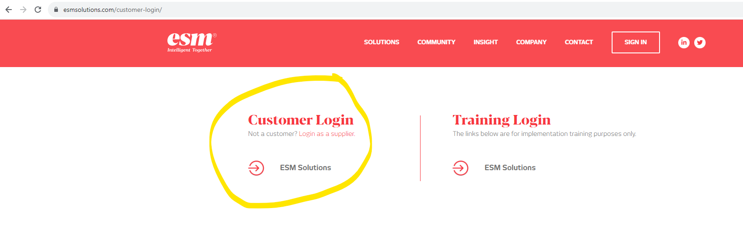2. Enter your email address and password here:
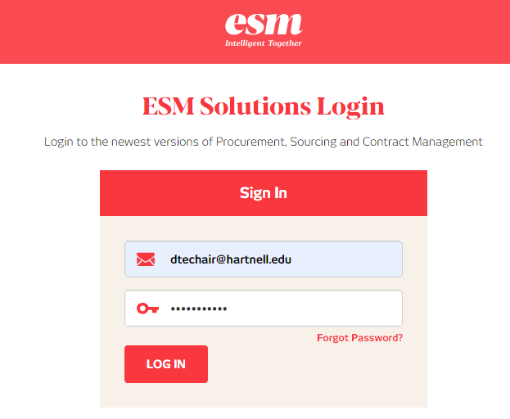
- To enter a requisition, click “Shop” at the top left to enter a manual requisition. Then click on “Non-Catalog Items”. Manual requisitions are for suppliers with no Catalog available (i.e. suppliers other than Blick Art Materials, Carolina Biological, CDW, or ODP Business Solutions-Office Depot).

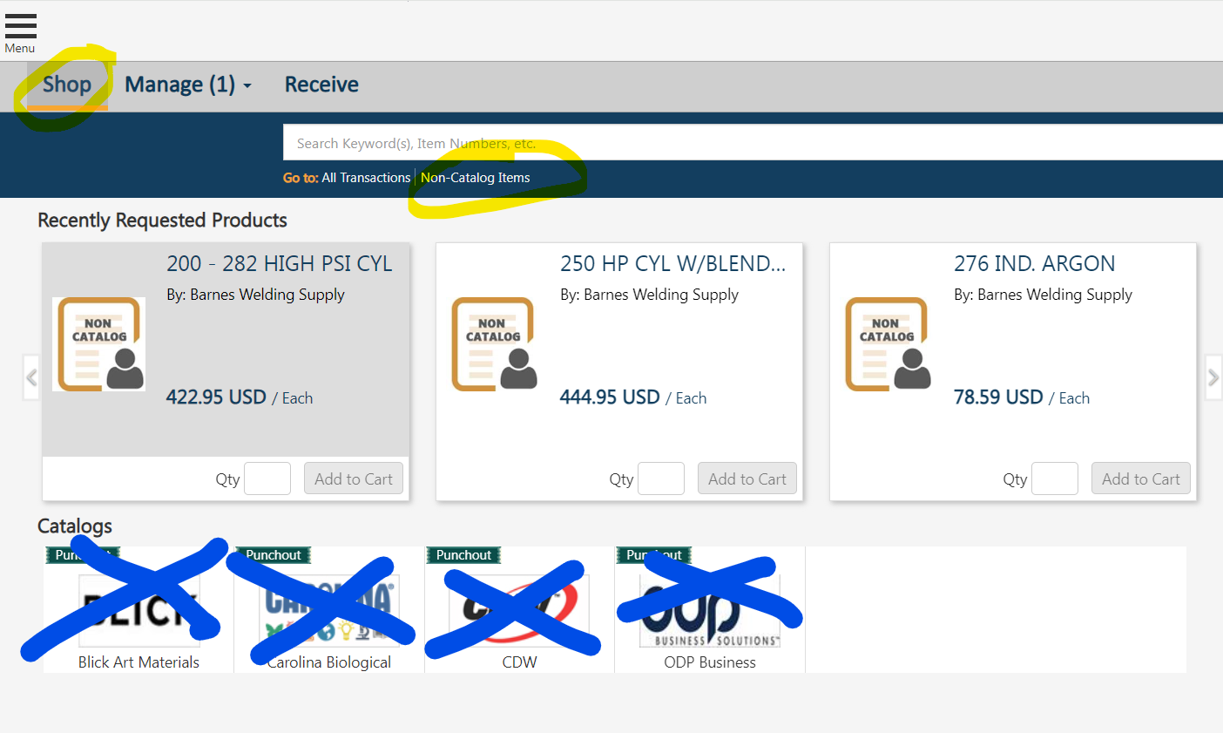

- A “New Non-Catalog Item” screen will appear. Type in the name of the supplier and click “Select” to proceed.
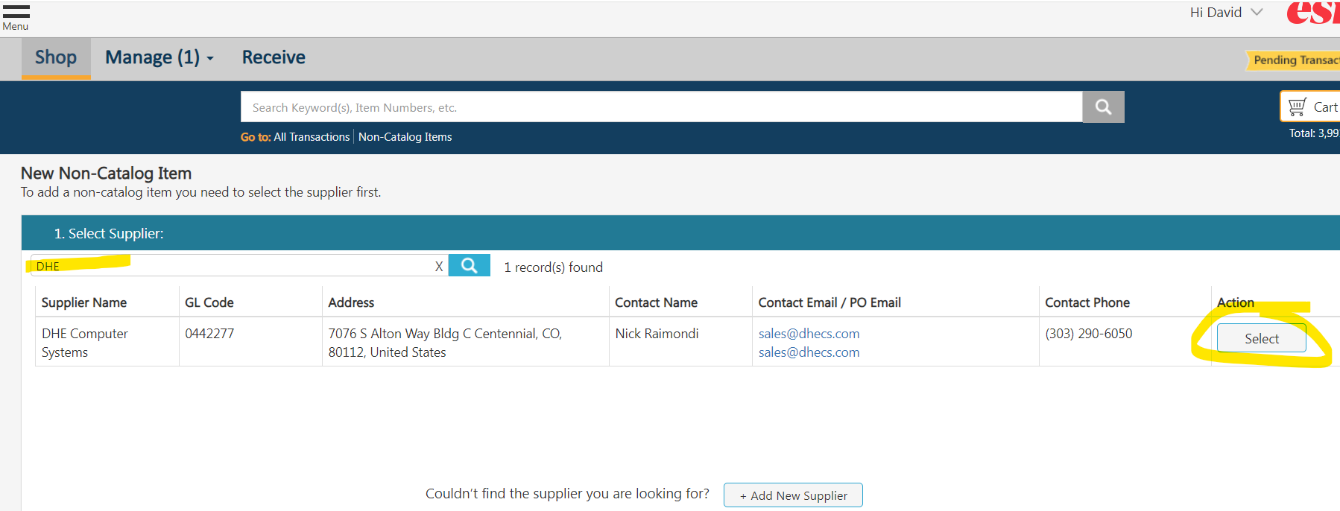
- Enter each line item on the quote you have. Enter the Item/Service, Qty, List Price, and Catalog Item# (this is the vendor/supplier’s item#). When complete, click on “Add to Cart” to proceed. 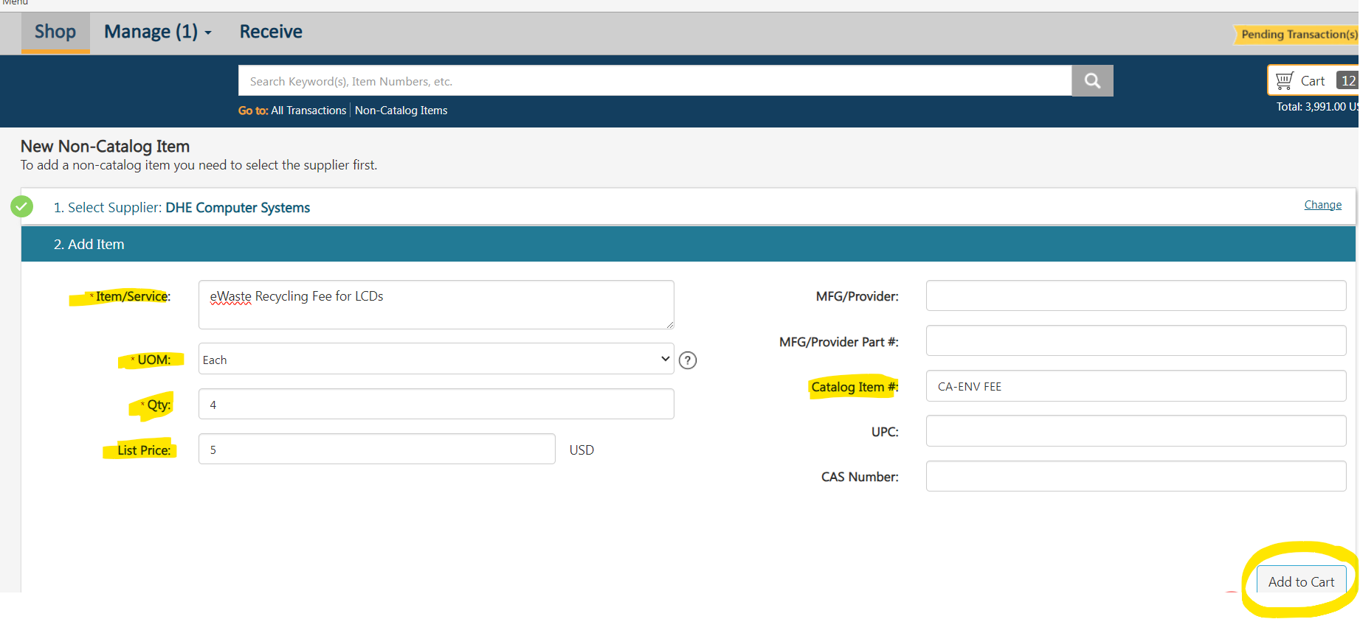
- ESM will allow you to enter another item if needed. When you are done adding each item from the quote, click on your “Cart” at the top right.
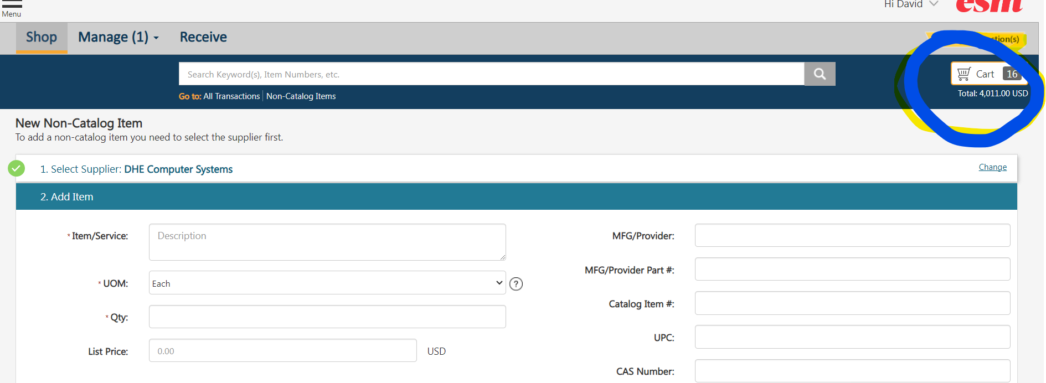

- Upon clicking on Cart, you will presented with an Item Summary page as shown below. Review the information, amounts, etc. If everything looks okay (i.e. the Cart Total matches your quote), click “Checkout.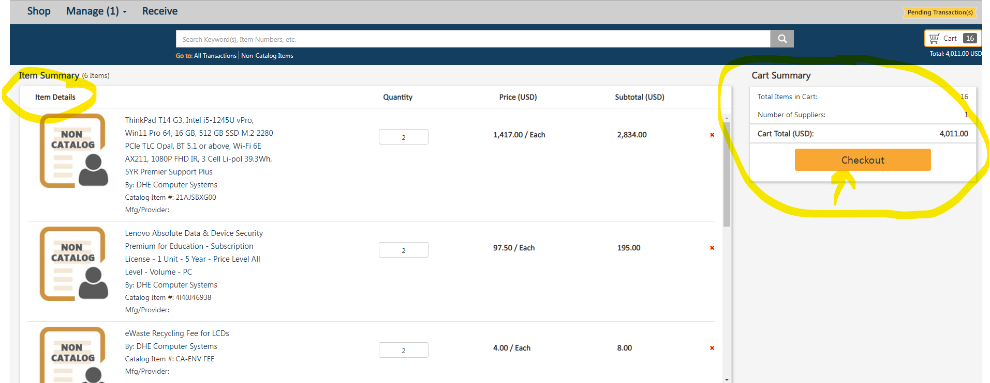
- ESM will then ask if you want to continue. Click “No” if you need to make edits. If okay to proceed as is, click “Yes” 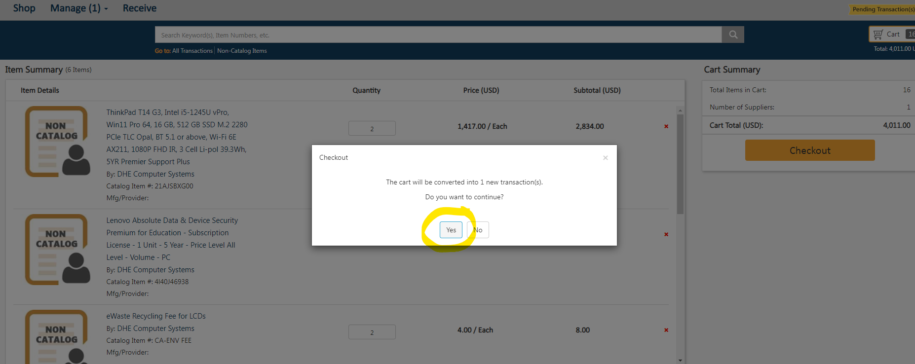

- You’ll be presented with the Checkout screen below. Review each section.
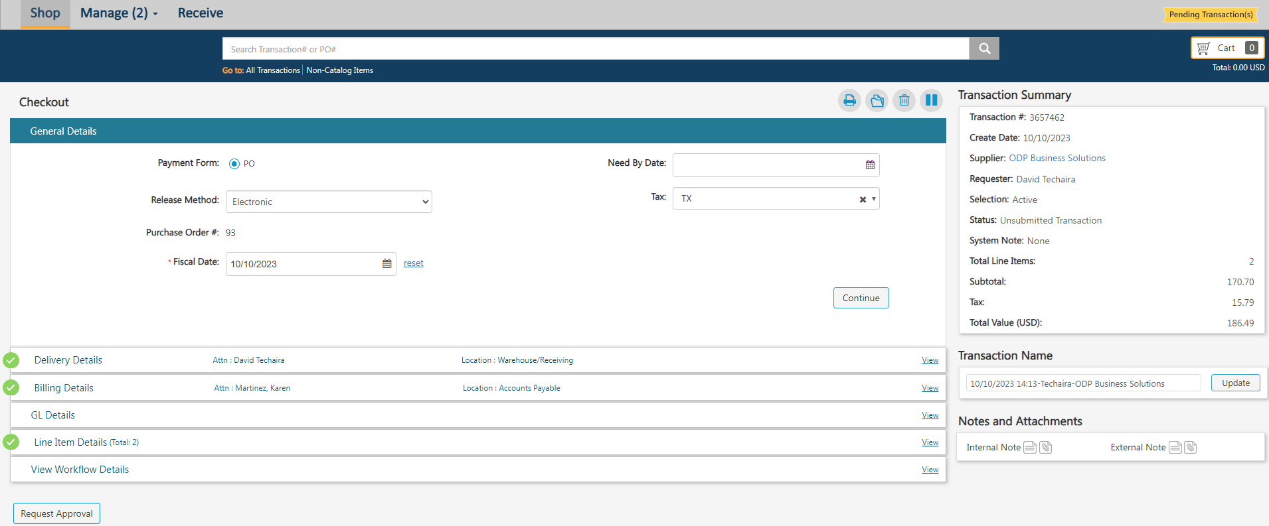
d1. The information in the “General Details” section will default. You will not need to change anything, so press “Continue” to proceed to the next section.
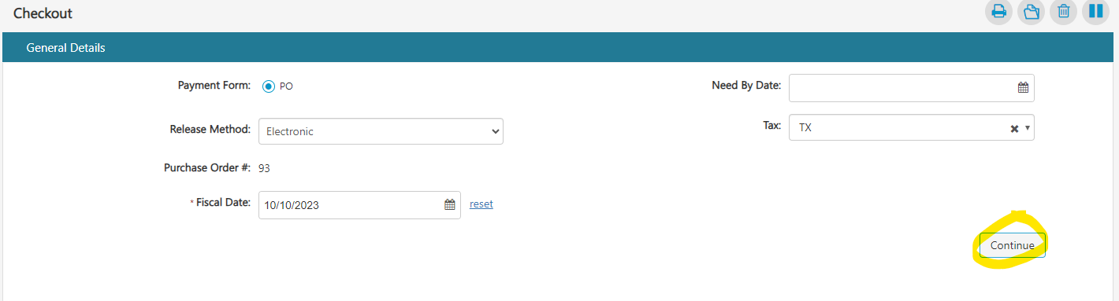

D2. In the “Delivery Details” section, enter the person’s name to receive the order in the “Ship To – Attn:” field. Then search and select the delivery location and click “Continue.”
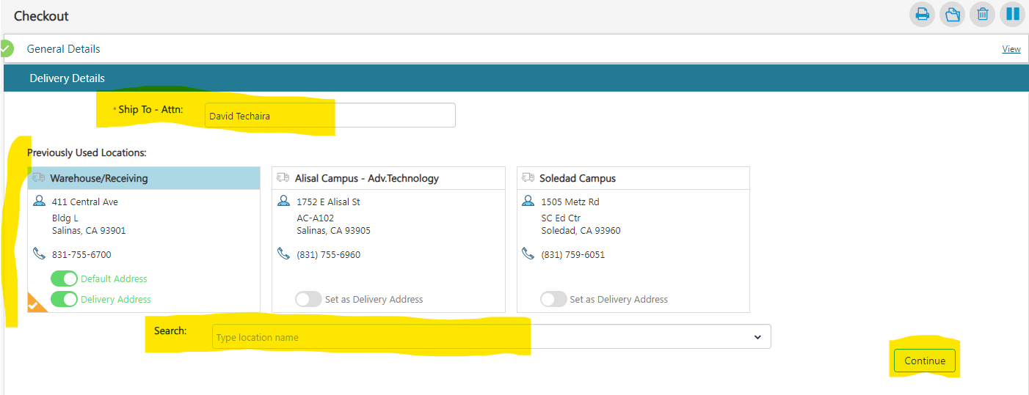
D3. In the “Billing Details” section, click “Continue.” No information should be changed here.
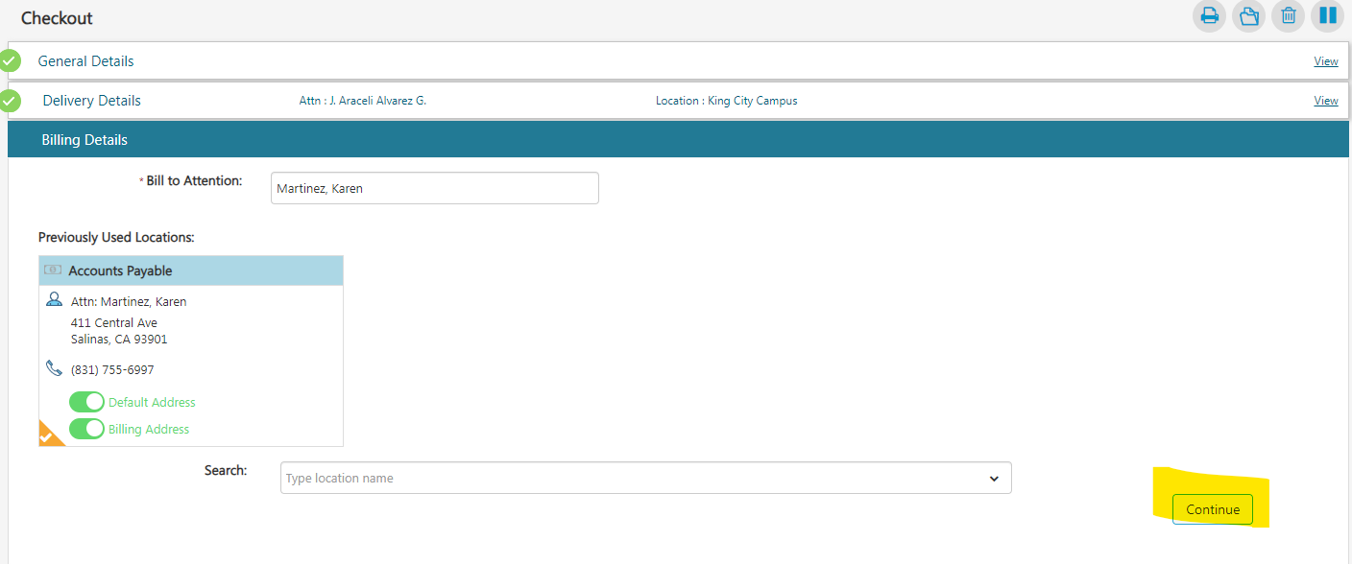
D4. In the “GL Details” section, account numbers must be entered. Click on the + sign at the right and enter the account number components (Fund, Area, Location, TOPS, Object). Click “Apply” when finished.
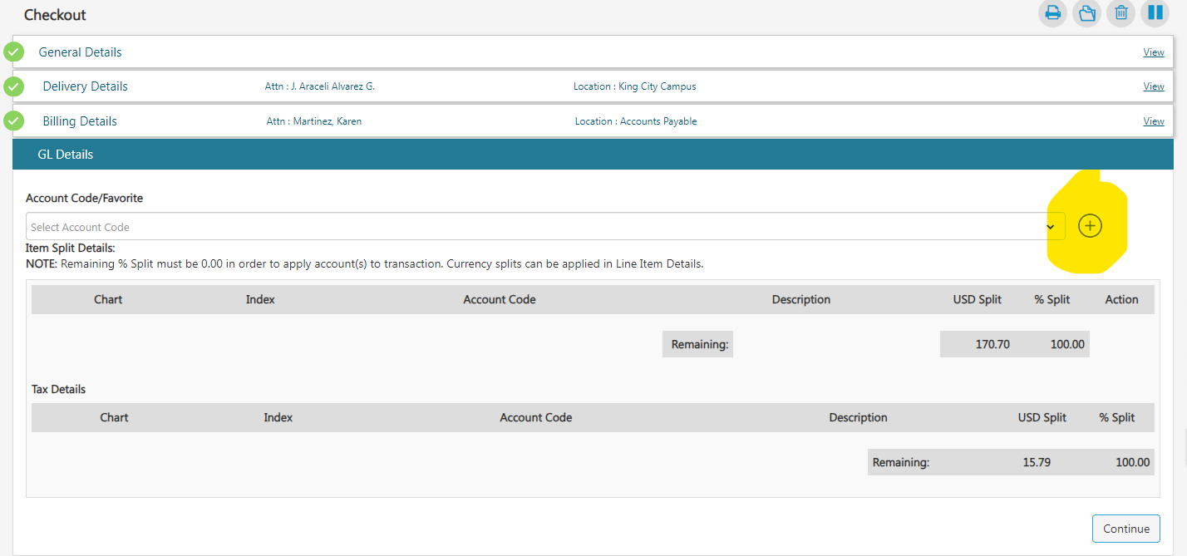
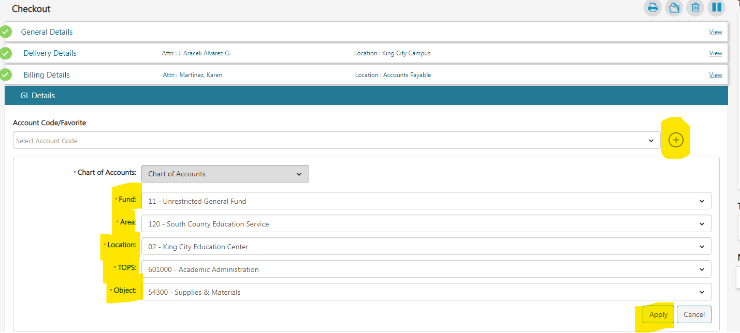
Review the gl account information for accuracy and click “Continue”
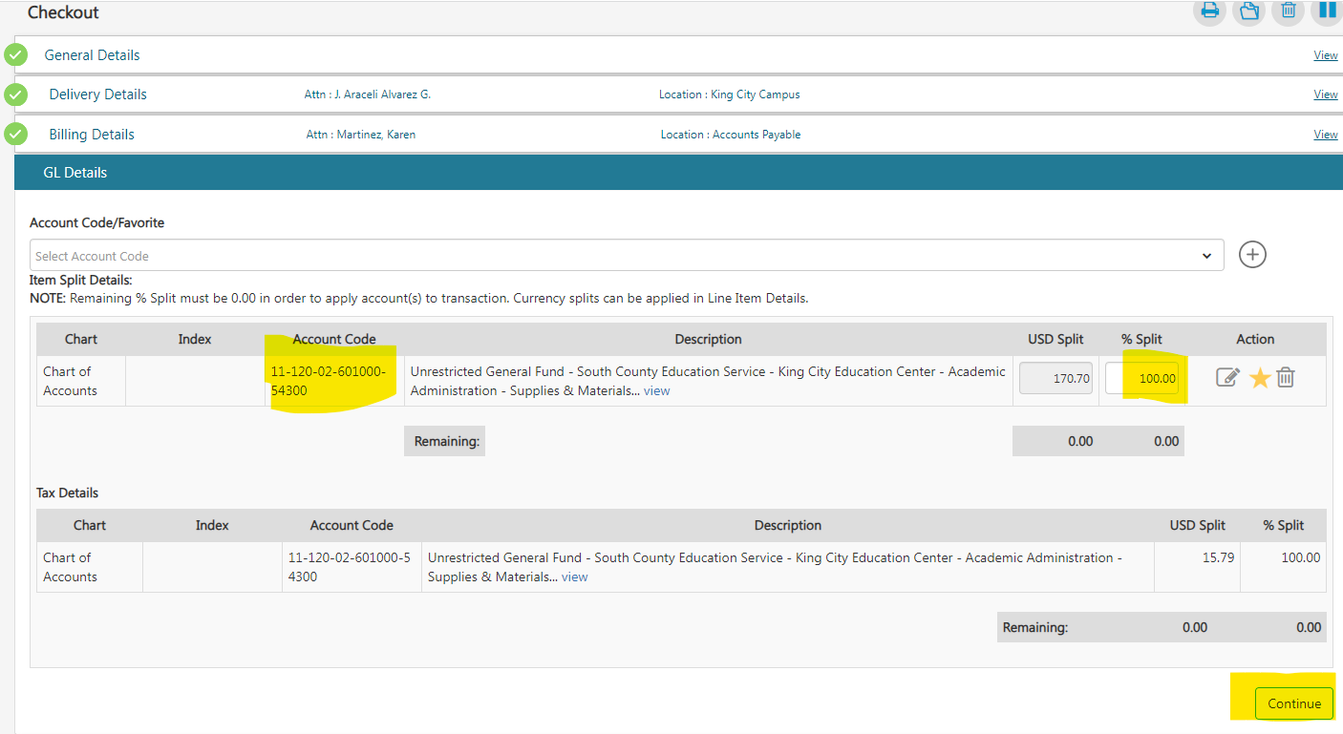
D5. In the “Line Item Details” section, review/confirm the information and click “Continue”
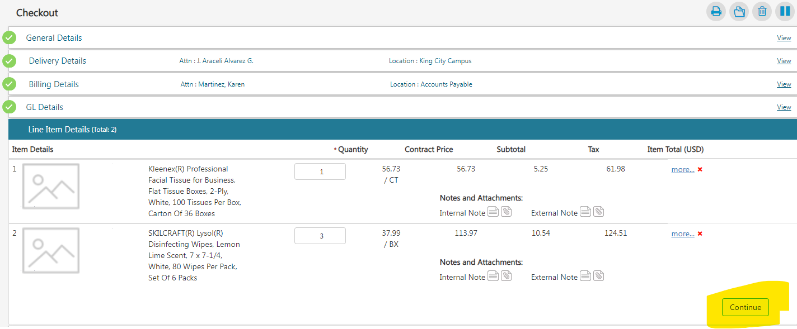
D6. The last section, “View Workflow Details” will show you who the request will get routed to for approval. Nothing can be changed here, but let Purchasing know if the routing is incorrect.
D7. If you have quotes and/or notes to provide, do so at the bottom right corner under the “Notes and Attachments” section. Click on either the notes icon or attachment icon and provide inputs/attachments. Please note that attachments in the “Internal Notes” section do NOT get sent to the vendor. Attachments in the “External Notes” section get sent to the vendor, so notes should include the quote/proposal number, and the attachment should be the actual quote/proposal document the vendor provided.
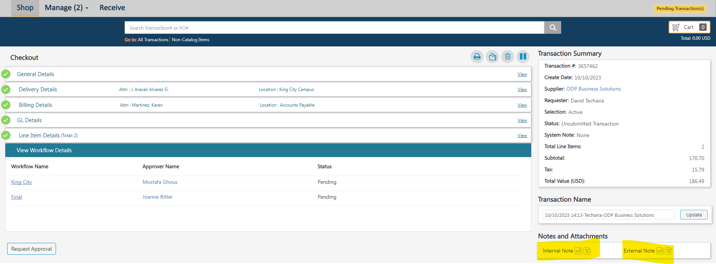
To attach documents, select the paperclip icon and a screen will open to allow you to attach. Select “Choose file” at the right, find the document to attach, and click “Update.” You’ll return to the checkout page.
D8. After reviewing order information and providing notes/attachments, click “Request Approval” and your requisition will be finalized and routed for approval. You’ll receive a message to confirm that you want to submit your order.

