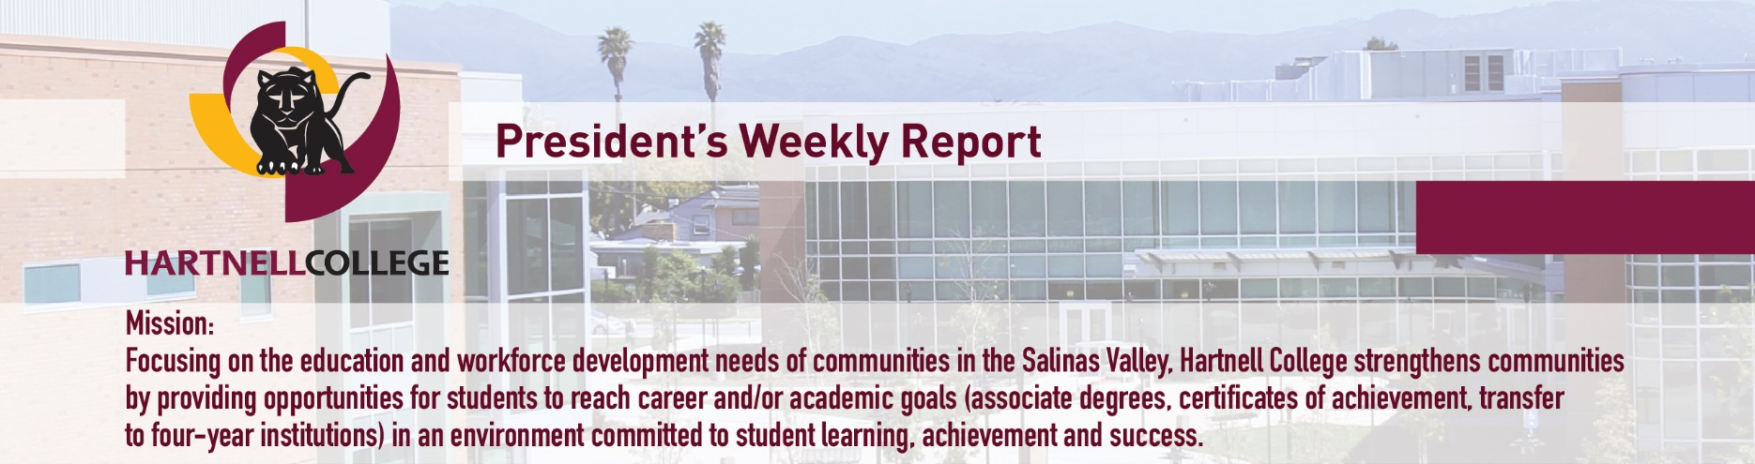
April 3, 2020

COVID-19 has not diminished
our focus on student success
Simultaneously supporting students, engaging employees and safeguarding public health amid the COVID-19 pandemic is a non-stop endeavor – one we are determined to accomplish as a college community. Students’ ability to achieve educational and career goals is essential not only for their futures, but also for the well-being of the Salinas Valley communities we serve.
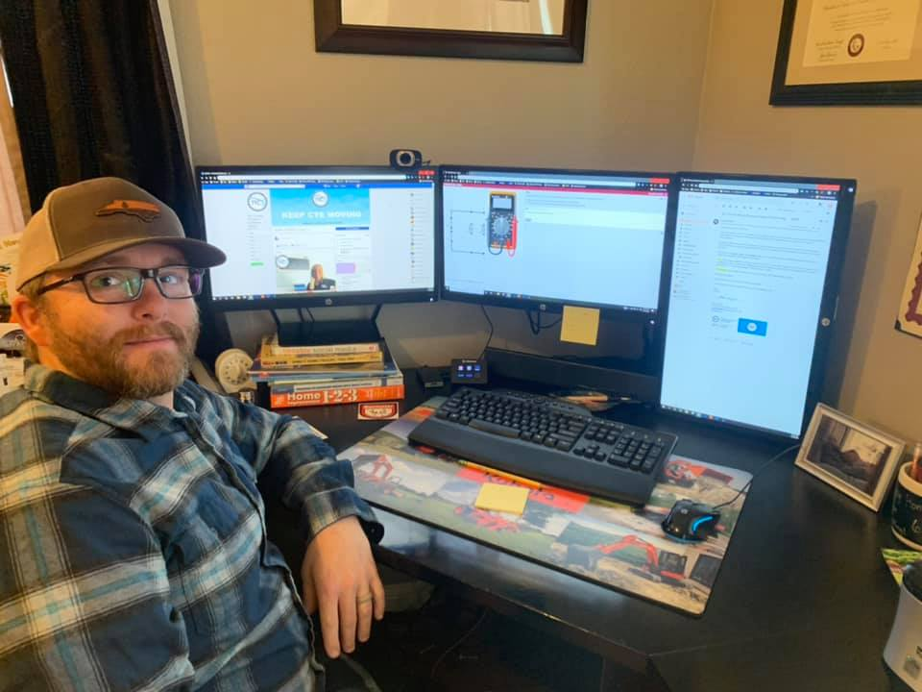
I am grateful to staff who are reaching out through the internet to encourage and assist students and to faculty who are creatively adapting face-to-face curriculum for online learning. An example is diesel technology instructor Mark DeHart, who on April 2 posted this Facebook photo of his home computer and monitors, set up for a lesson on digital multimeters. His hashtag: #KeepCTEMoving.

Our Information Technology Resources (ITR) team, led by Vice President Dave Phillips, opened a free student wireless hotspot in our Building J parking lot on March 27, and six days later they added a second hotspot at the King City Education Center, with a third coming soon on the Alisal Campus. ITR also is coordinating distribution of hundreds of brand new Chromebook laptops to students who need that tool, beginning with those poised to complete their degrees this spring. The laptops are among several needs to be funded through the Hartnell College Foundation’s COVID-19 Student Emergency Response campaign, which employees and friends of Hartnell are encouraged to support via the foundation’s online giving page.

Hartnell donates ventilators, supplies
as nursing students gain experience
Hartnell is contributing directly to medical efforts to treat patients with COVID-19 and others needing care by its loan of 13 ventilators from our respiratory care program, the donation of such critical supplies as masks, gowns and gloves; and the participation of 88 registered nursing students at Salinas Valley Memorial Hospital (SVMH).

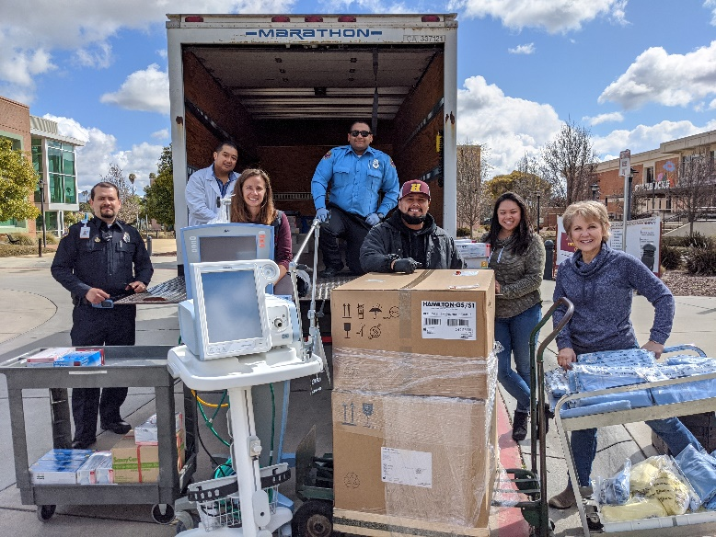
There also is the prospect for students in our respiratory care, nursing and the emergency medical technician program to be recruited as part of California’s Health Corps group being organized to supplement shorthanded health care staffs across the state. That effort was announced on March 30 by Gov. Gavin Newsom.

Dr. Debra Kaczmar, dean of academic affairs, nursing and allied health, said the pressing demand for nursing help in non-COVID roles at SVMH will fulfill remaining clinical requirements for 2020 RN graduates and enable second-semester students to continue their hands-on learning, despite COVID-19’s impact on classroom simulation.

Vocational nursing students have been less fortunate, she said, because local skilled-nursing facilities have restricted opportunities for them to accumulate patient-care hours at this time. Respiratory care students also have been displaced from clinical postings, but the program’s upcoming graduates already have sufficient experience to begin working, Dr. Kaczmar said, and several have job waiting at Santa Clara Valley Medical Center in San Jose.

Many of the RN and respiratory students, in particular, expressed a determination to contribute during the pandemic, she said.

“It’s like, ‘Yes, this is what I want,’” Dr. Kaczmar said. “‘This is what I should be doing.’ ‘What can I do to help?’ and so on.”

Pictured, from left: SVMH staff pick up ventilators and medical supplies for use in treating COVID-19 patients, joined by Hartnell staff ― warehouse technician Joel Ledesma-Calderon; Nursing and Allied Health Lead Program Coordinator Belinda Saechao-Jimmeye and Dr. Debra Kaczmar, dean of academic affairs, nursing and allied health.

College Redesign process advances
toward 2020-21 implementation
With support from the College Planning Council and Academic Senate, and following a March 6 implementation retreat for Inquiry & Design teams and senior college leaders, the student-success initiative known as College Redesign will become a reality during the next academic year.

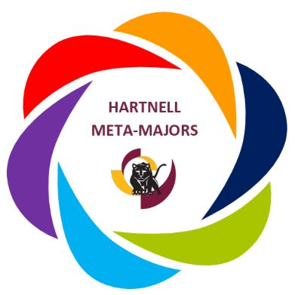
Inquiry was the focus during 2018-19; this academic year was dedicated to design development and approval; and 2020-21 is when the implementation of approved designs will begin contributing to student success, completion and employment. Especially noteworthy are the meta-majors, the foundation of the Guided Pathways method of steering students into broad categories of academic programs, even if students are unsure about their specific career plans.

Dr. Hetty Yelland, College Redesign Guided Pathways coordinator, said next steps include selection of 10 faculty co-leads for implementation and compilation of a survey to assess employees’ interest in participating on implementation teams next year. A virtual awards ceremony to celebrate the work of College Redesign participants is scheduled for May 4.

“We are excited about celebrating all the hard work that has paid off with success,” Dr. Yelland said. “We should be proud that we accomplished so much this year.”

During Convocation 2020 in August, College Redesign will have an unprecedented three hours to begin systematic and comprehensive program mapping for Guided Pathways. Counseling and instructional faculty meta-major co-leads will facilitate the collaborative work of all counseling and instructional faculty on this process.

Among plans advanced by the six college redesign teams, composed of administrators, staff, faculty and students: facilitated forums for employee engagement; a welcome center and pre-enrolled student map for adult and non-traditional students; pre-semester events open to all students (Guiding Panthers to Success ― GPS); development of a continuing students experience; and development of an exit system for completing students.

Panther Learning Lab provides
tutoring for online students
The Panther Learning Lab is delivering all-online tutoring to support Hartnell students who are completing all-online classes through the spring semester and on into summer as a result of the COVID-19 pandemic.
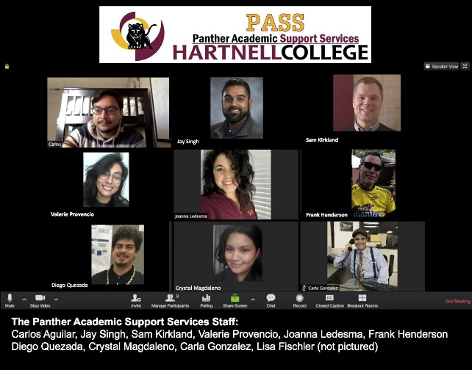
On a typical day before students were asked to stay home, between 40 and 80 students would visit the lab for English and Science, Technology, Engineering and Math (STEM) tutoring, and the tutoring team is hoping to build back to assisting that many students online.

“It is really important to make sure we are operating well to provide students with the academic support to help them succeed in class,” said Jay Singh, director of academic and student support services. “The partnership with faculty will be key in letting them know we are here for them.”

Members of the Online Panther Learning Lab team (pictured) are being creative in their use of technology. They are connecting with students via phone, but they are also using video cam and a whiteboard behind them to explain complex concepts. For English, for example, the student sends a shared Word Doc and the tutor is able to help edit it in real time.

Carla Gonzalez, also an academic support specialist, had a clear message to share with all students: “We’ve got you, and you’ve got this.”

Read the full story here.

CCC Football Coaches Association
inducts Shaw into its Hall of Fame
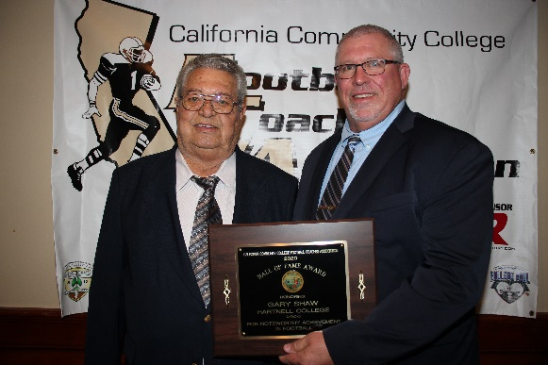
Hartnell Athletics coaching great Gary Shaw joined the California Community Colleges Football Coaches Hall of Fame in a March 14 induction ceremony (pictured, at left).

Shaw, who coached track, cross country and football over a 37-year Hartnell career, was recognized for his 19 years as an assistant football coach for the Panthers, beginning in 1970. He served with three different head coaches: Tony Teresa (1970-74), Ken Uselton (1975) and Marv Grim (1976-87).

He is best known as a head coach for track and cross country, in which his teams earned 62 Coast Conference championships during his Hartnell years.

Shaw called the Hall of Fame induction a “great honor” and paid tribute to “great head football coaches who know how to put together a coaching staff.”

“During the ‘70s and ‘80s we had some good football teams,” he said.

ASHC application deadline nears
for April 22-24 online election
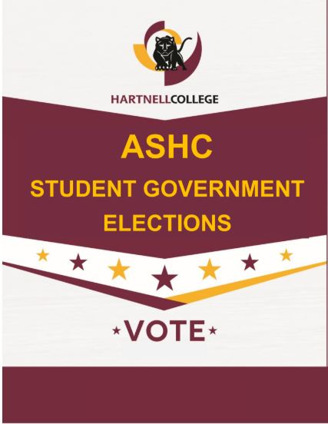
Aiming to repeat last year’s strong participation through online voting, the Office of Student Life and current Associated Students of Hartnell College (ASHC) leadership is seeking a full slate of officer candidates by an application deadline at 6 p.m. on April 10.
The online application can be found at ASHC 2020 Elections, or stop by the Office of Student Life for assistance. The online elections will take place April 22-24.
There are 15 positions available within the ASHC, and one Student Trustee seat. Officer positions are: Executive Branch ― president, vice president, secretary and treasurer; Legislative Branch ― director of Inter-Club Council, director of public relations, director of programs and services, senators at large (five seats), senator for Alisal Campus (one seat), senator for south county (one seat), senator for evening/online/weekend (one seat).
Successful candidates will have the opportunity to build leadership skills, represent Hartnell students in shared governance, gain networking opportunities on and off campus and enrich their resume and college/scholarship applications. Stipends are available for ASHC officers.

In the News

College Kids: https://www.montereycountyweekly.com/news/local_news/tool-box-04-02-20/article_1bbd1414-7476-11ea-88a0-ab814418affd.html

Californians support COVID-19 U.S.-Mexico border closure, even s it separates families: https://www.thecalifornian.com/story/news/2020/04/01/californians-support-border-closure-even-keeps-them-family/5078815002/

Upcoming Events
Note: All campus events are canceled until further notice in compliance with a statewide shelter-in-place order.
HCCD Governing Board
Regular meeting (social distancing observed)
5 p.m.
Tuesday, April 7
Steinbeck Hall (Building C)

Pop-Up Pantry food distribution
12 p.m.
Friday, April 10
Hartnell Parking Structure
411 W. Central Ave.

HCCD Governing Board
Development meeting (social distancing observed)
5:30 p.m.
Tuesday, April 21
Steinbeck Hall (Building C)

Pop-Up Pantry food distribution
12 p.m.
Friday, April 24
Hartnell Parking Structure
411 W. Central Ave.

