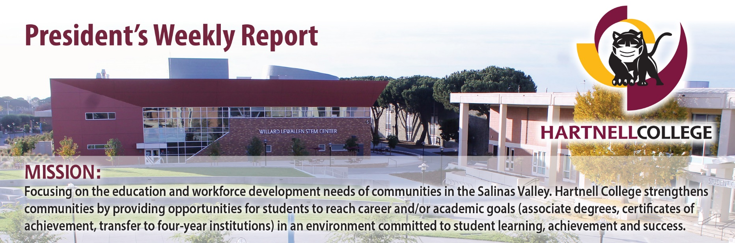
Share your news!
March 04, 2022
December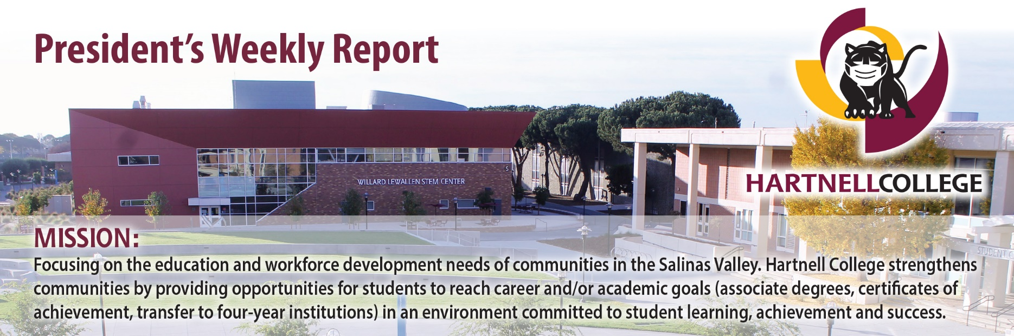, 020
The President’s Weekly Report highlights accomplishment, engagement, progress and success for and within the Hartnell College Community. Please send information and photos by each Wednesday to sfaust@hartnell.edu.

Superintendent/President finalists
will present at forums on March 11

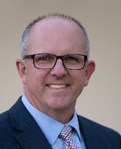
The Hartnell Community College District Governing Board has announced three finalists for the position of Superintendent/President, who will introduce themselves to the college and the greater community during 45-minute open forums on March 11 in Steinbeck Hall (Building C)

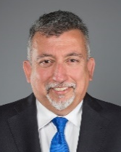
- 1 p.m. – Dr. Brian Sanders, vice president of instruction for Columbia College (Sonora, Calif.) since 2016, previously dean of science, engineering and mathematics at Modesto Junior College, with a Doctor in Education degree in Educational Leadership from the University of California, Davis.

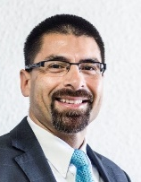
- 2 p.m. – Dr. Christopher Villa, president of Portland Community College from 2018-20, vice president of student services at Los Angeles Mission College (2015-18) and Fresno City College (2009-15) and vice president of student support services at Long Beach City College (2006-09), with a Doctor in Education degree in Educational Leadership and Policy from the University of Utah.

- 3 p.m. – Michael Gutierrez, president of Sacramento City College since 2017, previously executive vice president of Eastfield College in Mesquite, Texas, (2009-17), with a Master’s Degree in Public Affairs from the University of Texas.

The forums also will be broadcast live via Zoom, although those will be view-only, not interactive. The Zoom link is: https://cccconfer.zoom.us/j/ 97016283766. The webinar ID number is 970 1628 3766. For more information about the finalists and the open forums, please visit this webpage.
On behalf of the Governing Board, Board President Erica Padilla-Chavez expressed appreciation to all candidates who applied during a nationwide search and to members of the Superintendent/President Search Committee for their work in reviewing, interviewing and recommending applicants.

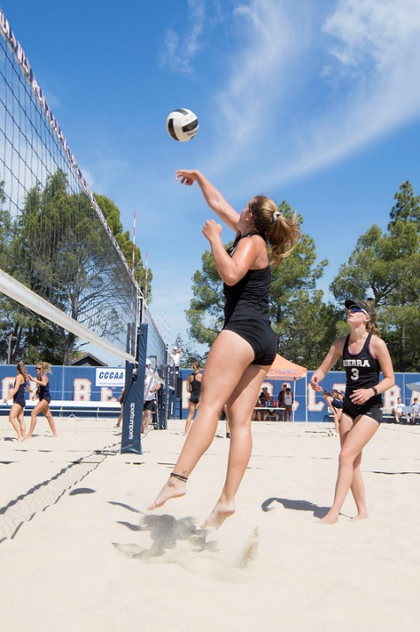
Governing Board hears plan to add
beach volleyball as women’s sport
Hartnell Athletics anticipates approval from the California Community College Athletic Association to add beach volleyball as an eighth women’s intercollegiate program, joining 42 other California community colleges that compete in the fast-growing sport.

Vice for President for Academic Affairs Dr. Cathryn Wilkinson presented the plan to the Hartnell Governing Board on March 1, joined by Volleyball Head Coach Jamie Pedroza, who will coach the new spring sport if it receives the go-ahead.

Pedroza anticipates having a squad of about 14 women, who will compete in 2-on-2 matches as ranked pairs. The team would practice and compete at Toro County Park or Fort Ord Dunes State Park. Many of the players would likely also play volleyball in the fall, benefiting from the opportunity to play on the sand for more months of practice and competition in a different setting. That will increase their skill level and prospects for recruitment by a four-year university. (Pictured: Sierra College competes during the 2018 CCCAA State Championship tournament.)
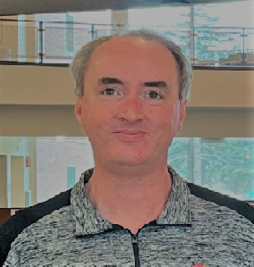
Dr. Guy Hanna is interim dean
of library and learning support
Dr. Guy Hanna, formerly outcomes and assessment specialist, in February stepped into the role of interim dean of languages, learning support and resources. He joined Hartnell in 2018 after previously serving as institutional research analyst for administration at the University of South Florida, among other positions in academic affairs, computers and information technology and research at several other institutions.

He has a doctorate in Leadership and Higher Education from Barry University and both a Master of Science and Bachelor of Science in Information Systems from Florida State University.

“I am excited to help all in the Salinas Valley who want to better their lives and community using the amazing resources we have here at Hartnell College,” Dr. Hanna said. “I firmly believe that an education is the only thing that can never be taken from you and that everyone deserves the right to critically think and determine their own path.”
Alisal Campus hosts FESTO group
for tour of new mechatronics lab
Clint Cowden, dean of career technical education and workforce development, and instructor Richard Chapman on March 1 hosted a tour group from FESTO, the company that supplied equipment for the newly installed manufacturing/mechatronics lab in the Alisal Campus’s Center for Advanced Technology.

Cowden shared how input from Salinas Valley agricultural employers was gathered and used to develop a curriculum for the program, which already has five non-credit classes and is planning to add five more in the coming year. Chapman was able to highlight the tremendous interest the new lab has generated, enabling Hartnell to launch one of just seven mechatronics programs in all of California.

Richard Chapman recognized as
new OSHA outreach trainer
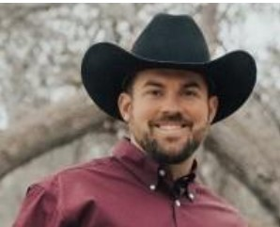
Agriculture engineering instructor Richard Chapman was featured in a March 2 newsletter published by the OSHA Training Institute Education Center in the Chabot-Las Positas Community College District for having become a newly authorized OSHA outreach trainer last summer. OSHA is the federal Occupational Safety and Health Administration.
Chapman, who joined Hartnell in 2020, is qualified to teach his Hartnell students the National Center for Construction Education and Research Core Course combined with the OSHA 10-Hour Outreach Training for General Industry, as well as an OSHA 30-Hour Outreach Training in General Industry. He also is exploring the opportunity to offer the OSHA 10-hour training to Salinas Valley employers.
Chapman said he has always taken a very practical approach to integrating safety into his teaching, always starting classes with specific safety instructions, including handling tools, project preparation and cleanup.
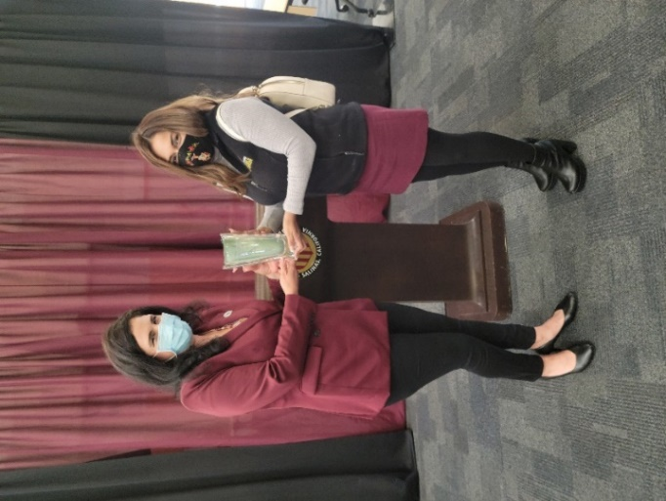
Gathering of well-wishers thank
Bronwyn Moreno for her service
Colleagues from across Hartnell gathered in Steinbeck Hall on March 4 to thank and recognize Bronwyn Moreno, director of student affairs for equity programs, on her last day at the college after 10 years of service. She is leaving to become chief program officer for DigitalNEST, a Salinas-based non-profit organization that trains young adults for technology-related careers. She started at Hartnell as program director for MESA, which promotes STEM achievement among educationally disadvantaged students, before becoming a student affairs director in 2015.

Governing Board member Candi DePauw was first to speak at the event, hailing Moreno’s role in developing such programs as Mi CASA for undocumented students, WELI and MILE for returning students and the Salinas Valley Promise for first-time, full-time students. “There are a lot of good people here that spend a lot of time helping students,” DePauw said, “but Bronwyn has certainly been at the top of the list.”

Jackie Cruz, vice president of advancement and development, presented Moreno with a crystal vase from the Hartnell College Foundation and “the Hartnell Family” inscribed with a message recognizing her “dedication to improving the lives of our students.”

Moreno thanked everyone for their support and appreciation, saying, “To have the opportunity to work with all of you over these last 10 years, I felt I truly grew up, and it was because of my relationships and partnerships with all of you. It’s reassuring to know that this beautiful Hartnell family is still here because I’m still passionate about our students and our community.”

Western Stage presents British farce
‘Noises Off’ from March 11-27

The Western Stage presents British playwright Michael Frayn's farce, involving a hapless cast and crew in a play within a play, for three weekends from March 11-27 at the Center for Performing Arts.
Labeled “the funniest farce ever written” by The New York Post, “Noises Off” will conclude the company’s COVID-delayed season, postponed from 2020 to 2021-22. Jon Patrick Selover, TWS’ retired artistic director, returns to direct and celebrate his two decades of leadership.
Performances are at 7:30 p.m. on Friday and Saturday and 2 p.m. on Sunday in the Mainstage Theater, Building K, on Main Campus. Hartnell employees can buy tickets for $15, rather than $26, and Hartnell students are admitted free with a current Hartnell ID. For more information, visit westernstage.com or call (831) 755-6816.

Drawing tickets on sale for $25
to support employee fundraising
The Hartnell College Foundation continues to sell $25 tickets for three opportunity drawings to support Employees for Student Success fundraising. The drawings are for tickets to the AT&T Pebble Beach Pro-Am, a Cancun vacation and a lot of 10 bottles of wine. Five tickets are $100.
The Cancun trip is eight days and seven nights at Vidanta Riviera Maya resort for a family of four, and there are four separate sets of two AT&T golf tickets to be awarded, one for each day of the tournament in 2023.
Contact the Foundation Office at 831.755.6810 to purchase tickets or to join the Employees for Student Success!

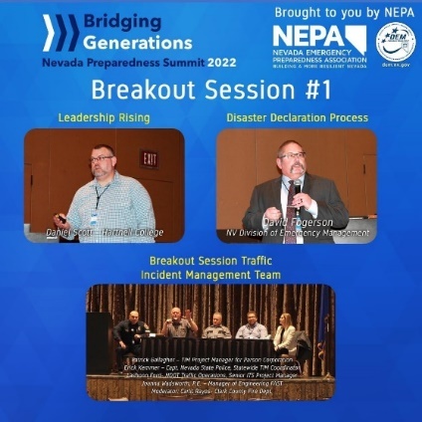
Daniel Scott presents on leadership
at Nevada Preparedness Summit
Daniel Scott, director of public safety and emergency management, presented in a breakout session on “Leadership Rising” on Feb. 23 during the Nevada Preparedness Summit, organized by the Nevada Emergency Preparedness Association.
Scott spoke on the growing trend of senior emergency management positions in organizations and how a new generation can prepare to step into those decision-making and leadership roles.

Women’s Track wins Wildcat Cup;
softball stays close to .500 after 18

The Hartnell Women’s Track & Field team won the Wildcat Cup on March 4 in Santa Rosa, and in the men’s team placed second among nine community colleges. The Panther women also won the meet in 2019, before it had to skip two years because of the pandemic.
Among highlights for the women was 3.15-meter pole vault by freshman Lorraine Mankins, moving her into a tie for the Northern California lead and placing her sixth on Hartnell’s all-time ranking. Fellow freshman Roxana Ruelas won the 400-meter low hurdles. Freshman Isabella Reimann won the hammer throw with a throw of 44.09 meters. For the men’s team, runners Isaac Gensel, Esteban Diaz and Francisco all won individual victories and qualified for state. Maciel won the steeplechase with a new meet record of 10:11:15.
Softball: The Panthers have won three of their past seven games since Feb. 19, maintaining a season record of 8-10 and also staying close to even in conference competition, 2-3. They next play at home in a doubleheader against Porterville on March 13.
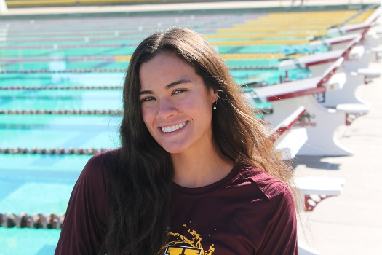
Baseball: Hartnell has had a tough slog after winning two games in early going, and their record now stands at 2-15 overall and 0-1 in conference. Come out and support the Panthers in their next home game this Tuesday, March 8 against Monterey Peninsula.
Swim/Dive: Freshman swimmer Kanyada Doughty from Salinas High School (pictured) continues to set Hartnell records, starting with 1.01.32 in the 100M butterfly, surpassing a mark of 1.04.3 that had stood since 1982.

In the News

Hartnell board announces superintendent-president finalists: https://www.montereyherald.com/2022/03/03/hartnell-board-announces-superintendent-president-finalists/

Hartnell’s rent and utility relief nears $7 million: https://kingcityrustler.com/hartnells-rent-and-utility-relief-nears-7-million/

College Athlete of the Week: https://www.montereyherald.com/2022/03/01/college-athlete-of-the-week-52/

Upcoming Events

Baseball vs. MPC
2 p.m.
Tuesday, March 8

Tony Teresa Diamond

Softball vs. Gavilan
3 p.m.
Tuesday, March 8
Hartnell Softball Field

American Red Cross Blood Drive
8:30 a.m.-1:30 p.m.
Wednesday, March 9
Steinbeck Hall (Building C)

Veteran Services Center Open House
12-2 p.m.
Wednesday, March 9
Building C, room 138

Open Forums for Superintendent/President Finalists
1 p.m., 2 p.m. and 3 p.m.
Friday, March 11
Main Campus Steinbeck Hall

Baseball vs. Ohlone
1 p.m.
Saturday, March 12
Tony Teresa Diamond

Softball vs. CSM
3 p.m.
Tuesday, March 15
Hartnell Softball Field

Hartnell Governing Board -- Development Meeting
5 p.m.
Tuesday, March 15
Steinbeck Hall (Building C)

Baseball vs. Cabrillo
2:30 p.m.
Thursday, March 17
Tony Teresa Diamond

Swim/Dive Meet
11 a.m.
Friday, March 18
Hartnell Pool

Baseball vs. Mission
2:30 p.m.
Tuesday, March 22
Tony Teresa Diamond

Softball vs. Chabot
3 p.m.
Tuesday, March 22
Hartnell Softball Field

