

Contact Person
Angelica Godoy-Rodriguez, Financial Aid Technician
(831) 755-6811
agodoy-rodriguez@hartnell.edu
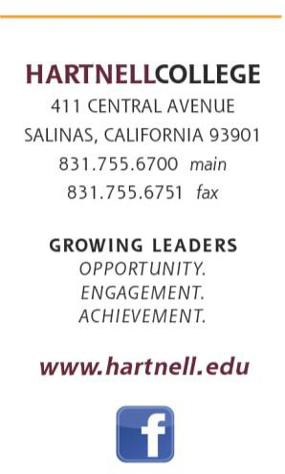
FINANCIAL AID & SCHOLARSHIPS
American Association of University Women, Monterey Chapter

Apply February 09, 2024 – March 31, 2024

Requirements:

• Cumulative college GPA of 3.0 or better.
- Completion of the Scholarship application and essay questions.
- Two Letters of Recommendations. One must be from a professor!
- Copy of an unofficial transcript.
- Completion of sufficient credits by end of current school year to transfer to a 4-year college or university in Fall following the end of the current academic year (May/June).
• Projected minimum full-time academic class load for the next semester indicating college or university where transferring student has been accepted.
• Willingness to participate in a personal interview, if selected.

Please turn in complete applications either in person in Building B-121 to the Scholarship’s
Office, or email agodoy-rodriguez@hartnell.edu before the deadline!

Interviews may take place in April 2024.

Name: Date:




American Association of University Women, Monterey Chapter Scholarship Application

Deadline is DATE 03/31/2024
Gender: Male Female

Address: City: State: Zip: Home Phone: Cell Phone:
Email:
Last 4 digits of SSN#:
Hartnell Student ID #:
Please print (Black or Blue Ink only):
First name: Last: MI:
I. CONTACT INFORMATION

Hartnell College Units Completed: SP24 Units: Cumulative GPA:

II. ACADEMIC INFORMATION

  - SCHOLARSHIP AREA

Some scholarships are awarded to students based on specific majors, or areas of study. Please indicate your major, or area of study:
- Agriculture | - Aviation | - Earth Science | - History | - Photography
- ADJ | - Biology | - ECE | - Liberal Studies | - Psychology
- AOD | - Business | - Education | - Math | - Physics
- Art | - Chemistry | - Engineering | - Meteorology | - Social Science
- Automotive | - Computer Science | - English | - Music | - Theatre Arts
- Astronomy | - Construction | - Ethnic Studies | - Nursing | - Other:
- Athletics | - Digital Arts | - Geology | - Oceanography

Please state your career objective:

Check any of the following which apply to you:

- A.C.E. student | - ESL
- AB 540 Student | - Financial Aid Student
- Bilingual Languages spoken: | - First in family to go to college
- California Rodeo Salinas | - International Student
- CHISPA Resident | - Learning Disability
- Classified Hartnell College Employee | - Received Tutorial/Learning Assistance
- Dole Employee-Spouse/Child | - Re-entry Student
- Enrolled in Nursing Program | - Veterans of Monterey County
- EOPS
Extracurricular Activities & Community Involvement
- List any/all Hartnell sports in which you participate:

- List all campus activities in which you are involved (clubs, groups, etc.):

- Name all community service programs, organizations, etc. in which you are involved:

- Place of employment:

- List any scholarships for which you have applied during the last 6 months:

Please indicate the 4-Year college/university to which you will be transferring for the FALL 2024
semester:

IMPORTANT! If you later decide you will not be attending the college or university listed above, please notify the Scholarships Office as soon as possible.
B. FALL 2024 Transfer Students Only

Have you ever been awarded any honors, such as Dean's List or President's List? If so, please indicate the honor and the years in which you were awarded.

Signature of Applicant: Date:
I, the undersigned, verify I am the sole author of this application and all statements herein are
true and factual to the best of my knowledge.
III. READ AND SIGN
AAUW Supplemental Questions

Directions: This part is REQUIRED, please complete the following questions detailed and concisely. Attach a separate paper if needed.

- Who or what influenced your decision to continue with your education at Hartnell College?

- How has your community guided your educational path?

- Write regarding an issue you feel strongly about and how it has impacted your educational goal/s.

- Please give a statement regarding your financial need

- Evidence of financial need

Please provide two letters of recommendation.
One is REQUIRED to be from a professor.

Please state who they are, name, phone number, how long you’ve known them and email address.
Person 1:

Person 2:

