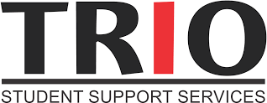

SSS TRIO Language Verification Form
Full Name | Student ID
What was your first language spoken?

ANSWER:

I certify, under penalty of perjury under the laws of the State of California, that I have provided complete and accurate responses to all the items on this form. My signature certifies the accuracy and completeness of the information provided, and releases SSS/TRIO to obtain educational documents and financial aid records to determine, enhance and/or report the effectiveness of the program and services provided to me. I also give my permission for SSS/TRIO personnel to share information with appropriate educators and college representatives as necessary to support my educational progress and academic success.

Student Signature Date

