Hartnell College Child Development Center

Welcome to Our Program!

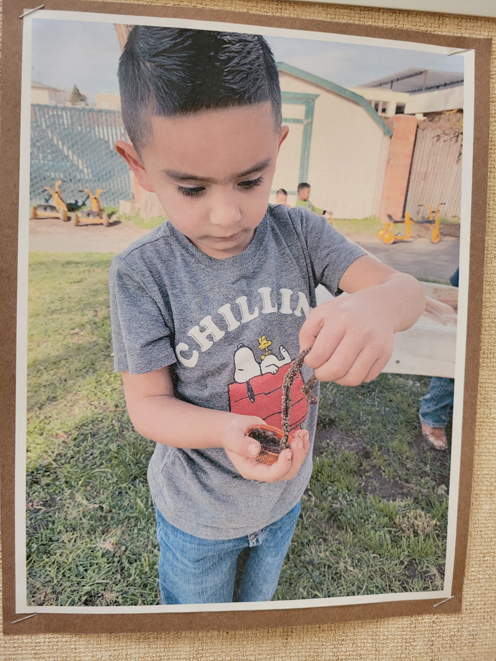

Admissions Policies and Procedures
*This program does not discriminate against students upon the basis of sex, sexual orientation, gender, ethnic group, identification, race, ancestry, national origin, religion, color, or mental or physical disability.

Our campus preschool lab serves up to 120 preschool-age children each year while providing observation and practicum experiences for students preparing for teaching and other child-related careers.

Our developmentally appropriate part-day preschool program is designed to facilitate the transition to kindergarten for the three-and four-year-old children. It includes educational development, health services, social services, nutritional services, parent education and parent participation, evaluation, and staff development.

Thank you for taking an interest in our program and your willingness to assist us in providing practical experience with children for our college students.

Program Location and Contact Information:
Hartnell College Main Campus-Building M
411 Central Avenue
Salinas, CA 93901
(831) 755-6945
cdc@hartnell.edu

Program Hours/Days
3 hours per day for a minimum of 175 days per school year.
Children may enroll for only one part-day period in either a morning or afternoon session

Office Hours:
8:00 a.m. to 12:00 noon and 12:30 – 4:30 p.m.
Closed 12 noon – 12:30 p.m.

Eligibility Determination
In order to be eligible for State-funded preschool, the family must meet at least one requirement as follows:
- The family is a current aid recipient;
- The family is income eligible;
- The family is homeless; or
- The family has children who are recipients of protective services, or whose children have been identified as being abused, neglected, or exploited, or at risk of being abused, neglected or exploited.

Family eligibility is established once each program year. The determination of eligibility is made without regard to the immigration status of the child or the child’s parent(s), unless the child or the child’s parent(s) is under a final order of deportation from the United States Department of Homeland Security. Enrollment may begin 120 calendar days prior to the first day of the beginning of a new preschool year. At the Parent Advisory Council meetings, participating parents are included in the decision-making process.

Residency Requirement
In addition to meeting eligibility and/or need requirements, to be eligible for services the child must live in the State of California while services are being received. Evidence of a street address or post office address in California will be sufficient to establish residency. A person identified as “Homeless” is exempted from this requirement and shall submit a declaration of intent to reside in California.
Priority for Enrollment
Priority of Services is as follows: (EC 8263[b][1]and [2])
First Priority: (EC 8263[b][1])
- Three – or four-year-old neglected or abused children who are recipients of child protective services; or are at risk of being neglected or abused.
- If an agency is unable to enroll a child in the first priority category, the agency shall refer the family to local resource and referral services to locate services for the child.
Second Priority: (EC 8263[b][2])
- After children in the first priority are enrolled, California State Preschool Program’s (CSPP) (EC 8235[b]) shall give priority to eligible four-year-old children who are not enrolled in a state funded transitional kindergarten program in income ranking order. Contractor shall certify that enrollment priority is being given to eligible four-year-old children.
- Second priority shall be given to eligible three-year-olds in income ranking order.
Age Eligibility
Beginning July 1, 2021, contractors must follow the age eligibility requirements for CSPP per EC Section 8208. The age eligibility requirements are as listed below:
- Children who have their third birthday on or before December 1 are eligible.
- Children who have their third birthday on or after December 1 may be enrolled on their third birthday.
- Children who have their fourth birthday on or before December 1 are eligible.
- Please note that children who will turn five-years-old between September 2 and December 1 of the fiscal year are no longer age eligible.
Prohibition of Religious Instruction and Worship
The Hartnell College Child Development Center child care and development services being provided do not include religious instruction or worship.

Child Application Process
Enrollment may begin 120 calendar days prior to the first day of the beginning of a new preschool year. A non-refundable $25 fee will be charged of all enrolling families at the time of enrollment. This fee is deposited in a dedicated fund to cover cost of all fieldtrips for the school year.

Complete initial application attaching income verification, and a copy of the birth certificate and yellow immunization card (front and back) or immunization printout from physician. Make sure proof of the chicken pox vaccine or verification of having had the illness is recorded on the immunization card. Additional proof of income or family size may be required to determine eligibility.

Make arrangements to tour the center and meet with a staff member. You are welcome to bring your child for the tour or arrange for a separate date for your child to visit.

If a space is available and it appears that you meet eligibility criteria for enrollment, you will be given an enrollment packet containing all admissions forms including a physician’s report form, which must be completed and signed by your child’s doctor within 30 days of admission.

If an opening is not available, you will be placed on the Waiting List in accordance with admission priorities and contacted as to the availability of a space in order of priority from the waiting list. When an opening comes available, we will make every attempt to reach you by phone and email. We will try for no more that 48 hours. If we do not get a response, we will move on to the next eligible person on the waiting list.

If it is determined that you are not income-eligible for the free preschool program, you may request a tuition schedule, program options and availability of a fee-based space in the program. The most recently approved fee schedule prepared and issued by the CDE when determining whether a family fee is applicable and the amount of a family’s fee.

Program Services

Children will be provided age-appropriate, planned, educational activities throughout each program day that address all developmental domains contained in the California Department of Education Desired Results Developmental Profiles (DRDP).

Assignment to a “Community”
A “Community” is a group of children assigned to a primary teacher. Child assignment is based primarily on chronological age with attempts made to balance the group by gender and home language. The class group is lead by an Early Childhood Education student that has successfully completed student teaching and has obtained a Child Development Teacher Permit. This “teacher” is responsible to plan activities to best meet the individual needs and developmental levels of the children in their group and for having the best understanding of the development of each child assigned to them. Therefore, this teacher is primarily responsible for completing each child’s portfolio and developmental profile and for conferences and communications with the parents of these children. Children begin and end each session in a community meeting with their primary teacher. The beginning community meeting activities may include greeting, checking-in, planning for the day, discussions, and sharing stories and songs. The ending community meeting activities may include saying goodbye, checking out, recalling the day’s activities, discussions, sharing stories and songs, and celebrating special situations, such as birthdays.

Parent Involvement and Education
The Child Development Center’s Parent Involvement and Education component includes the following:
- An orientation for parents that includes topics such as program philosophy, program goals and objectives, program activities, eligibility criteria and priorities for enrollment, fee requirements, and due process procedures.
- At least two individual conferences with the parent(s) per year.
- Parent meetings with program staff.
- An open door policy that encourages parents to participate in the daily activities whenever possible, and
- A Parent Advisory Committee that advises the contractor on issues related to services to families and children.

Ongoing sharing of information between staff and parents concerning their child’s progress.

NOTE: All parents and/or family members (18 years or older) that will be participating in the classroom must have the following immunizations in order to volunteer:
- Influenza (Optional)-Yearly
- TB/PPD – Less than 3 years old or less than 4 years old if x-ray or blood test
- Measles/Mumps/Rubella (MMR) – no time limit
- Diptheria/Tetnus/Pertussis (DTap) – no time limit

Confidentiality of Records
The use or disclosure of all information pertaining to the child and his/her family shall be restricted by Hartnell College to purposes directly connected with the administration of the program. Hartnell College shall permit the review of the family data file by the child’s parent(s) or the parent’s authorized representative, upon request and at reasonable times and places.

Due Process Requirement for the Free Preschool Program
Notice of Action (NOA)
Hartnell College’s decision to approve or deny services shall be communicated to the applicant by mailing or delivering a written NOA within 30 calendar days from the date the application is signed by the parent. If the services are denied, the notice shall contain the basis for denial and instructions for the parent(s) on how to request a hearing if they do not agree with the decision.

Parent’s Request for a Hearing and Procedures
If parent disagrees with an action, the parent(s) may file a request for a hearing with the contractor within fourteen (14) calendar days of the date the Notice of Action was received. Upon the filing of a request for hearing, the intended action shall be suspended until the review process has been completed. The review process is complete when the appeal process has been exhausted or when the parent(s) abandons the appeal process. Within ten (10) calendar days following the receipt of the request for a hearing, the contractor shall notify the parent(s) of the time and place of the hearing. The time and place of the hearing shall, to the extent possible, be convenient for the parent(s). The hearing shall be conducted by an administrative staff person who shall be referred to as “the hearing officer.” The hearing officer shall be a staff member in higher authority than the staff person who made the contested decision. The parent(s) or parent’s authorized representative is required to attend the hearing. If the parent or the parent’s authorized representative fails to appear at the hearing, the parent will be deemed to have abandoned his or her appeal. Only persons directly affected by the hearing shall be allowed to attend. The contractor shall arrange for the presence of an interpreter at the hearing, if one is requested by the parent(s). The hearing officer shall explain to the parents(s) the legal, regulatory, or policy basis for the intended action.

During the hearing the parent(s) shall have an opportunity to explain the reason(s) they believe the contractor’s decision was incorrect. The contractor’s staff shall present any material facts omitted by the parent(s). The hearing officer shall mail or deliver to the parent(s) a written decision within ten (10) calendar days after the hearing. The written decision shall contain procedures for submitting an appeal to the CDE.

Appeal Procedure for CDE Review
If the parent disagrees with the written decision from the contractor, the parent has fourteen (14) calendar days in which to appeal to the California Department of Education. If the parent(s) do(es) not submit an appeal request to the CDE within fourteen (14) calendar days, the parents’ appeal process shall be deemed abandoned and the contractor may implement the intended action. The parent(s) shall specify in the appeal request the reason(s) why he/she believes the contractor’s decision was incorrect. A copy of the contractor’s notice of intended action and written decision shall be submitted by the parents(s) with the appeal request. Upon receipt of an appeal request, the CDE may request copies of the family data file and other relevant materials from the contractor. The CDE may also conduct any investigations, interview, or mediation necessary to resolve the appeal.

The decision of the CDE shall be mailed or delivered to the parent(s) and to the contractor within thirty (30) calendar days after receipt of the appeal request.

Contractor Compliance with CDE Decision; Reimbursement for Services During the Appeal Process
The contractor shall comply with the decision of the CDE immediately upon receipt thereof. The contractor shall be reimbursed for child care and development services delivered to the family which is appealing during the appeals process. If a contractor’s determination that a family is ineligible is upheld by the CDE, services to the family shall cease upon receipt of the CDE’s decision by the contractor.

